**Cybersecurity Home Lab Project using Microsoft Sentinel 2025**

**Name:** Phanindhar Reddy Karnati

**Date:** 06/14/2025

**Table of Contents**

1. Azure Account Creation and Access
2. Resource Group Setup
3. Virtual Network and Subnet Configuration
4. Deploying the Windows Virtual Machine (Honeypot)
5. Configuring Network Security Group (NSG)
6. Disabling Windows Defender Firewall
7. Generating Simulated Attack Logs
8. Verifying Logs Using Event Viewer
9. Creating Log Analytics Workspace (LAW)
10. Deploying Microsoft Sentinel Instance
11. Enabling Log Forwarding with Azure Monitoring Agent (AMA)
12. Confirming Log Ingestion via KQL Queries
13. Uploading GeoIP Watchlist to Sentinel
14. Joining Security Logs with GeoIP Data
15. Visualizing Attacks on World Map (Attack Map Workbook)
16. Conclusion

## **Introduction**

This project outlines the creation and deployment of a cloud-based home Security Operations Center (SOC) using Microsoft Azure and Microsoft Sentinel. The lab provides real-world simulation experience by configuring a honeypot virtual machine (VM) to receive actual malicious traffic from the internet. Through this setup, we demonstrate how to monitor, analyze, and visualize attack patterns using security event logs, Kusto Query Language (KQL), and geographic enrichment via a custom IP-to-location watchlist. This lab is suitable for beginners, professionals, and cybersecurity students seeking hands-on SIEM experience that can be highlighted on resumes.

**1. Azure Account Creation and Access**

Before deploying any infrastructure, a free Azure subscription is created. Microsoft requires a credit card to verify the user. If a free account is unavailable, users may opt for:

* A pay-as-you-go Azure model (billed like a utility)
* Accessing Azure through the paid "Cyber Range" platform which includes other cybersecurity tools like Tenable

Once an account is active, users can access the Azure dashboard through [**portal.azure.com**](https://portal.azure.com)**.**

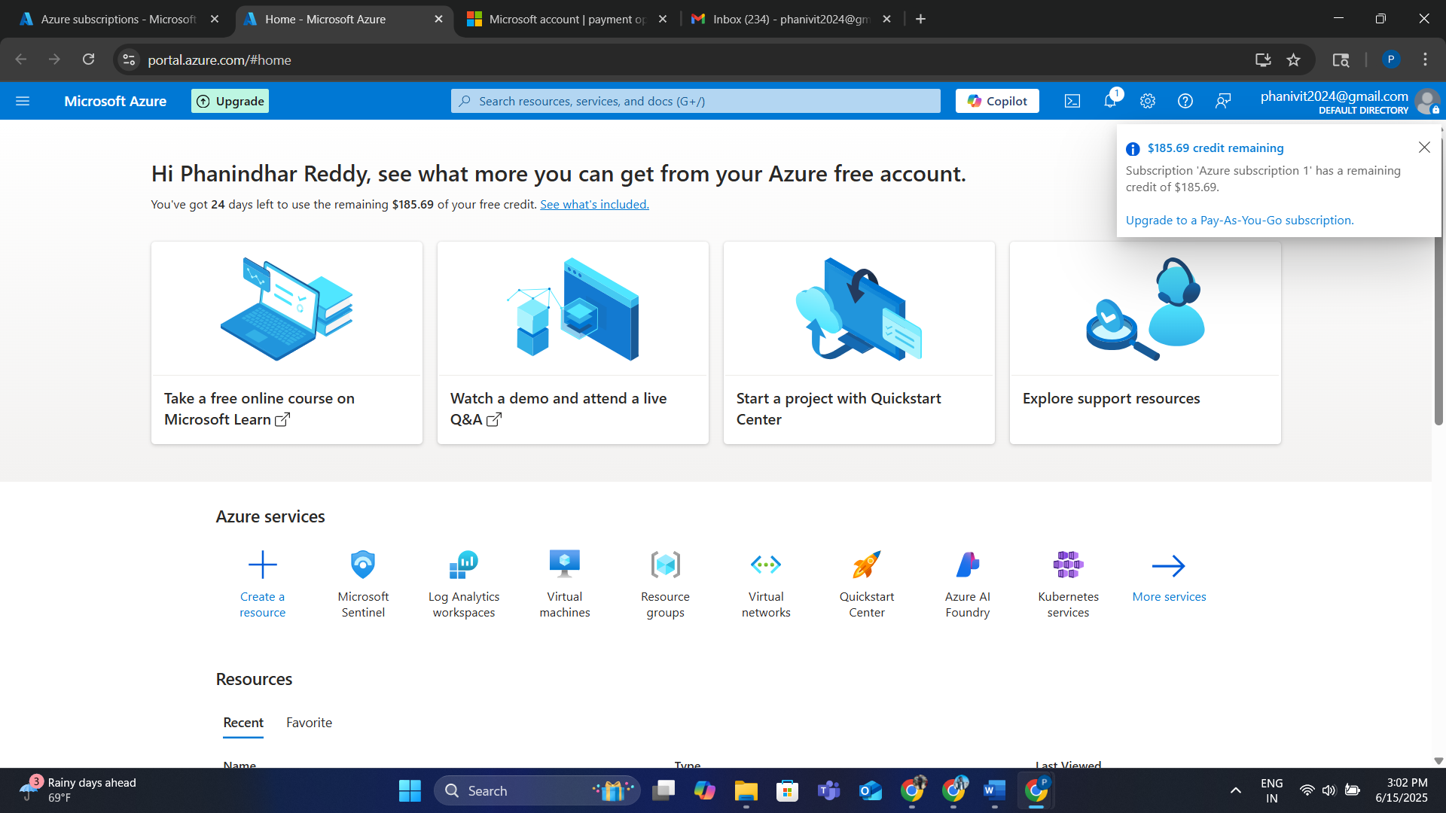

**2. Resource Group Setup**

Resource groups in Azure serve as containers for related resources.

* They allow easier management, deletion, and auditing of associated services.

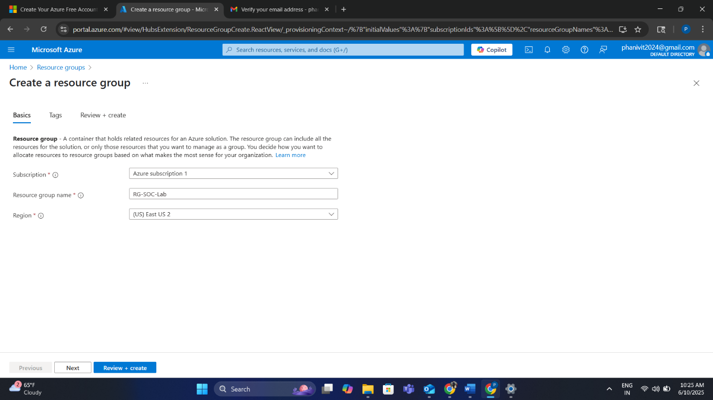

* We created a resource group named rg-socklab in the "East US 2" region to ensure data locality for our VMs and networking resources.

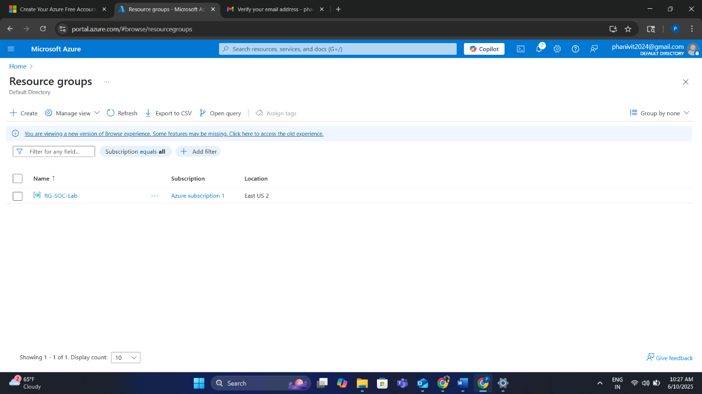

**3. Virtual Network and Subnet Configuration**

A Virtual Network (VNet) simulates a traditional networking environment in the cloud. It functions like a router at home, enabling internal communication and internet exposure:

* A VNet named vnet-socklab was created in the same resource group.
* A default subnet was automatically created within the VNet, enabling internal VM traffic.

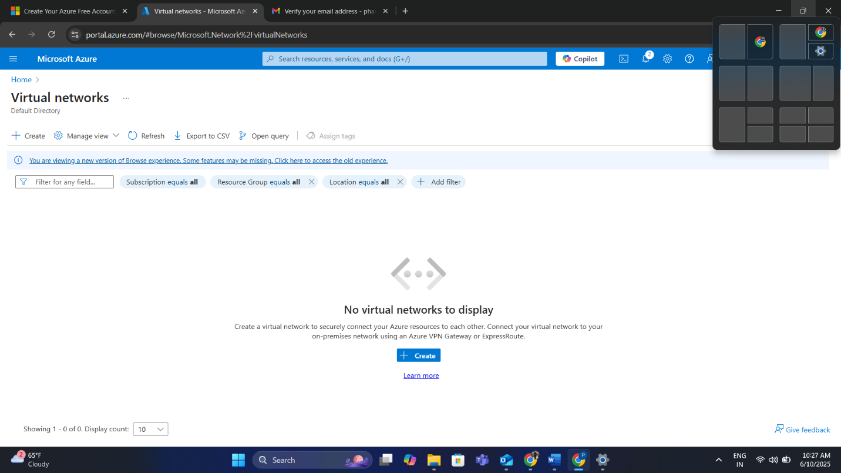

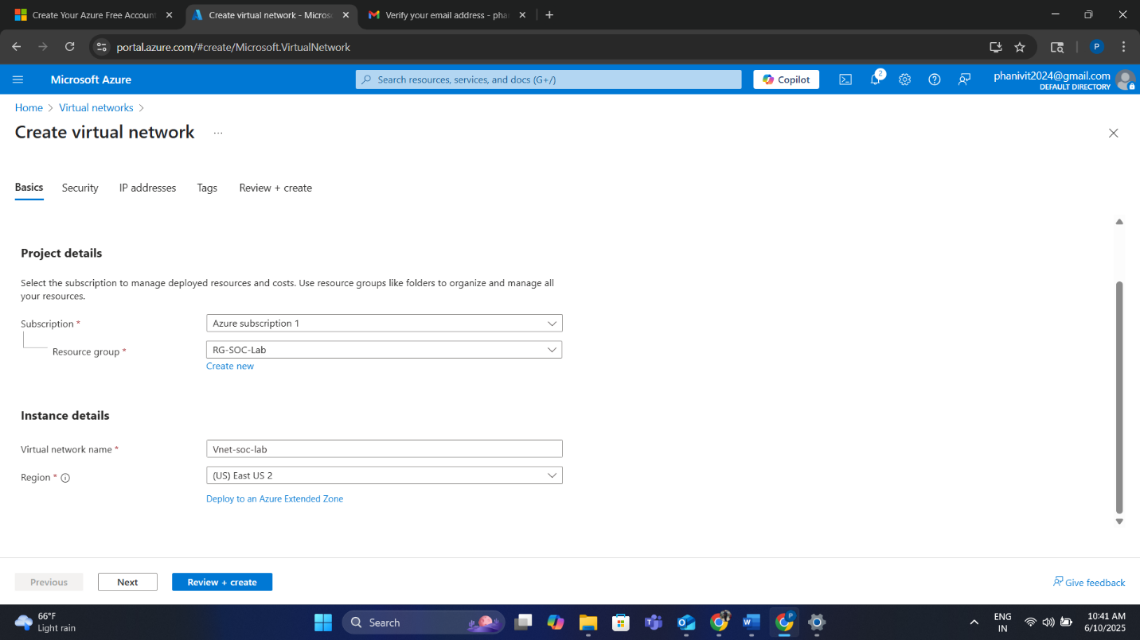

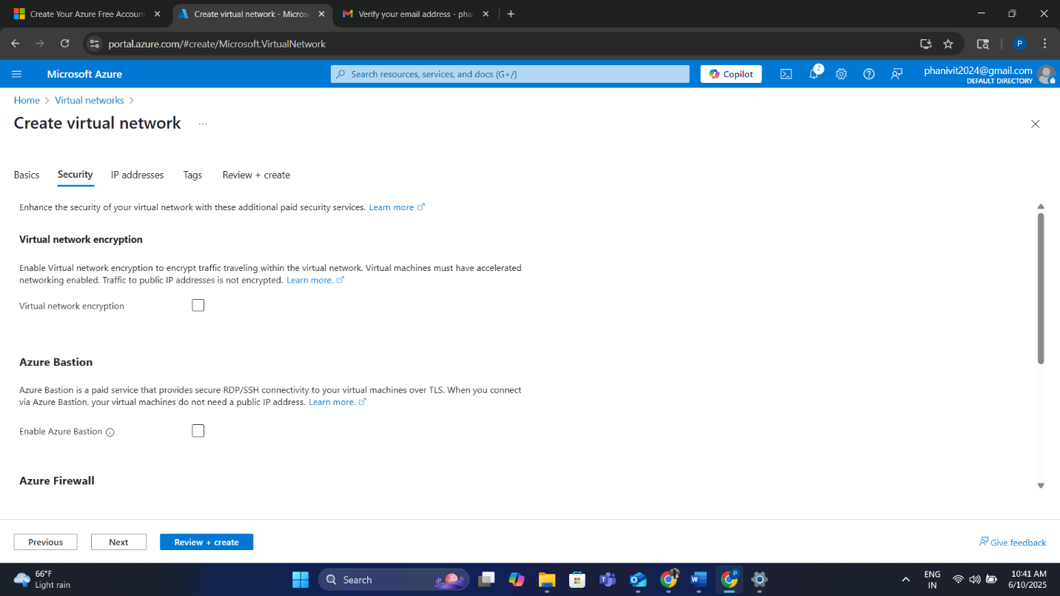

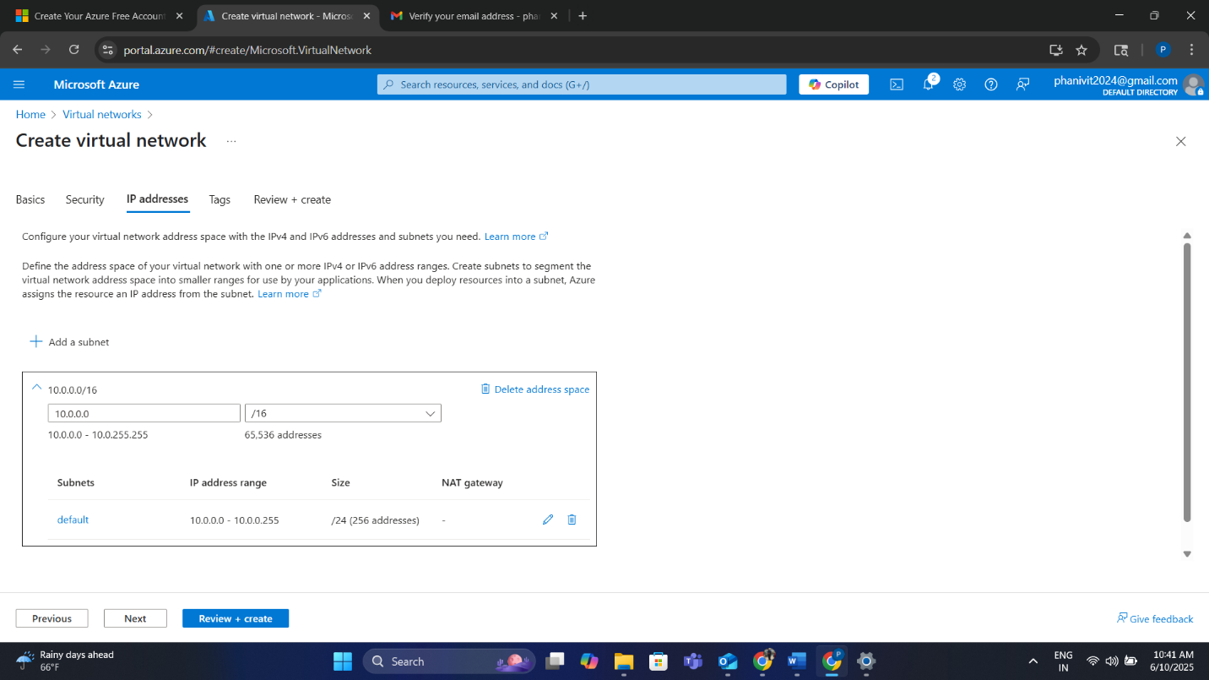

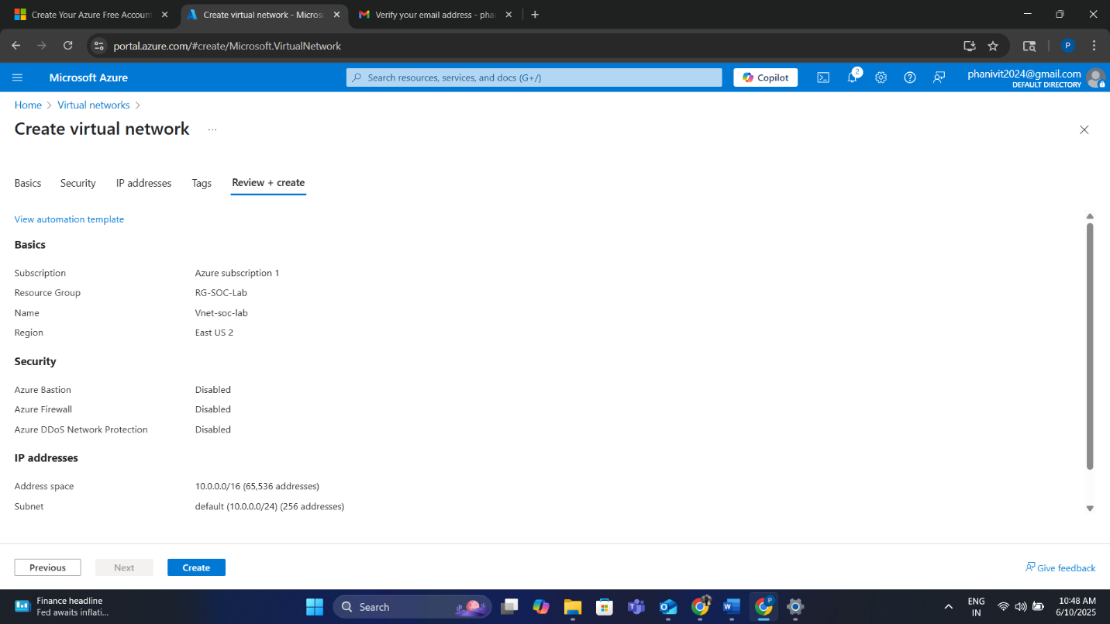

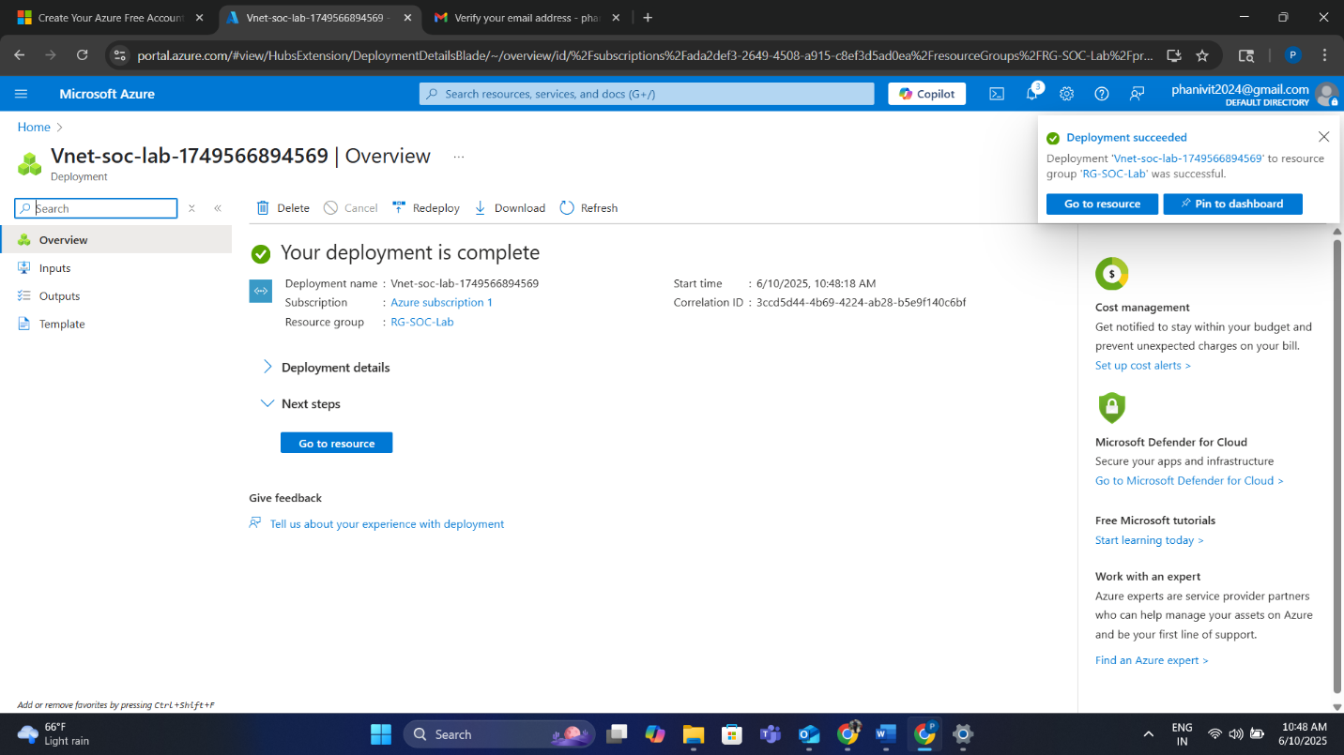

**4. Deploying the Windows Virtual Machine (Honeypot)**

The core of the honeypot lab is a Windows 10 VM deployed to attract unauthorized access attempts:

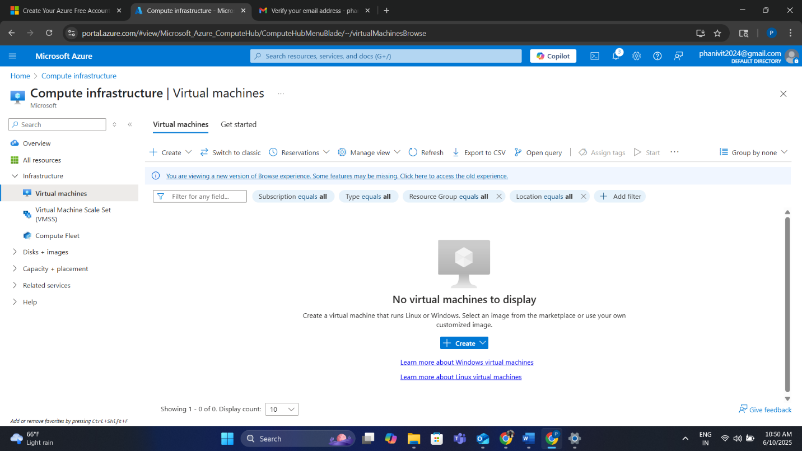

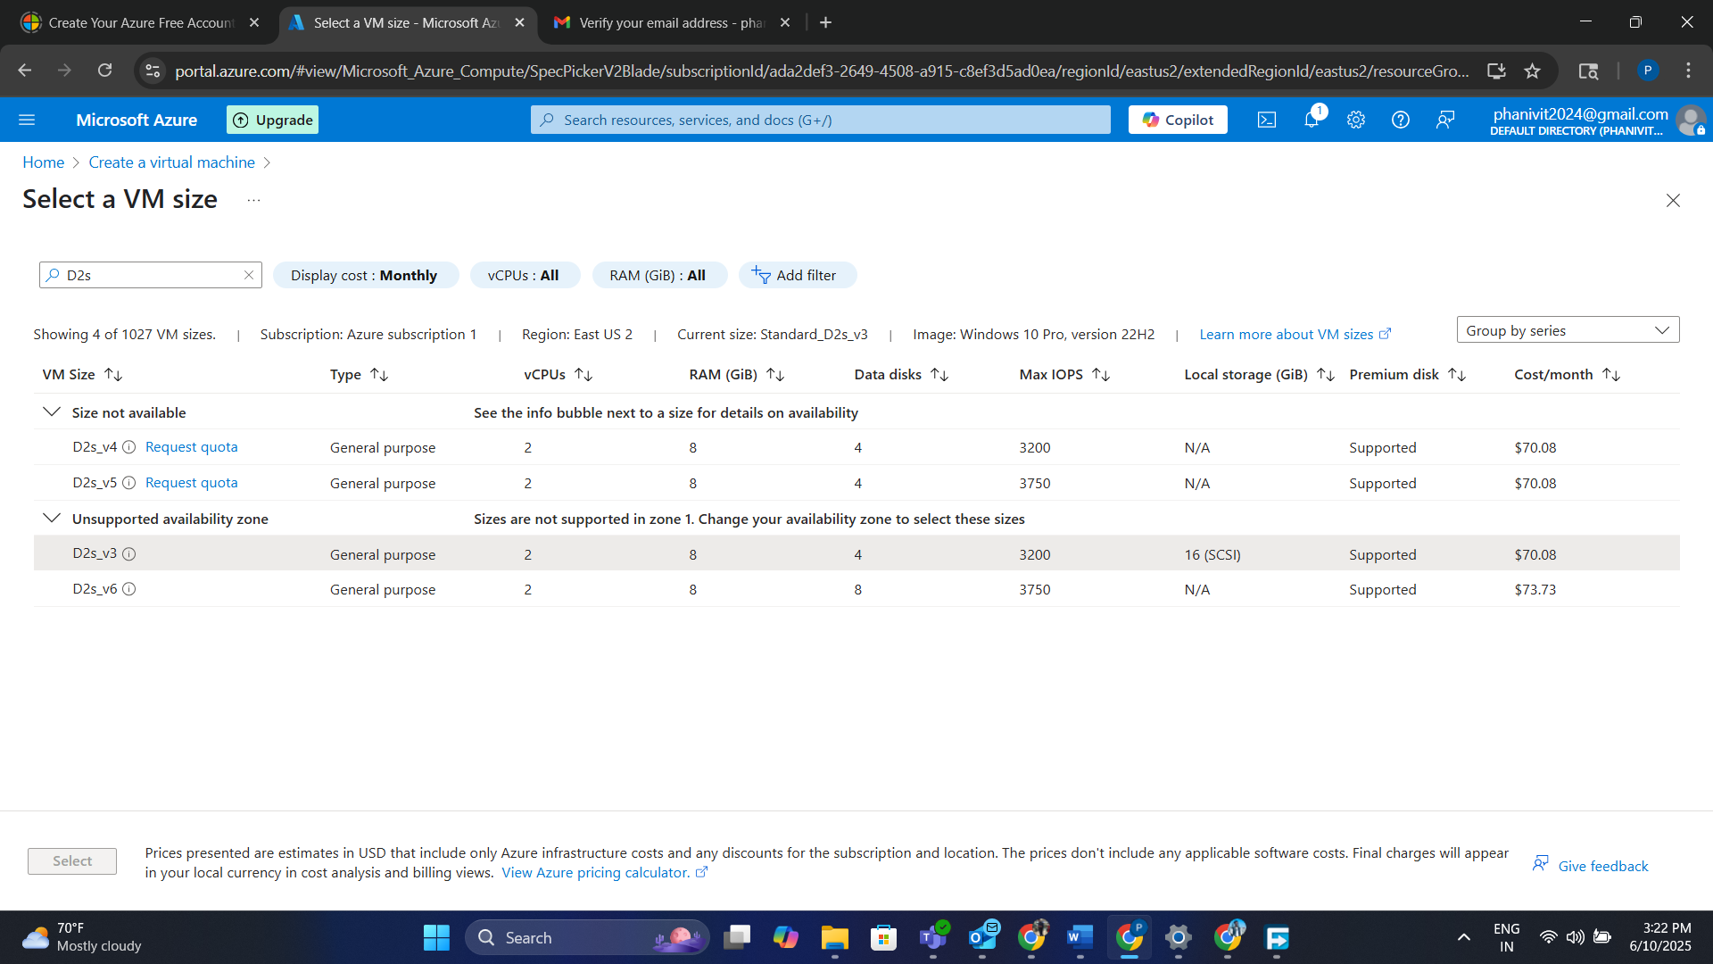

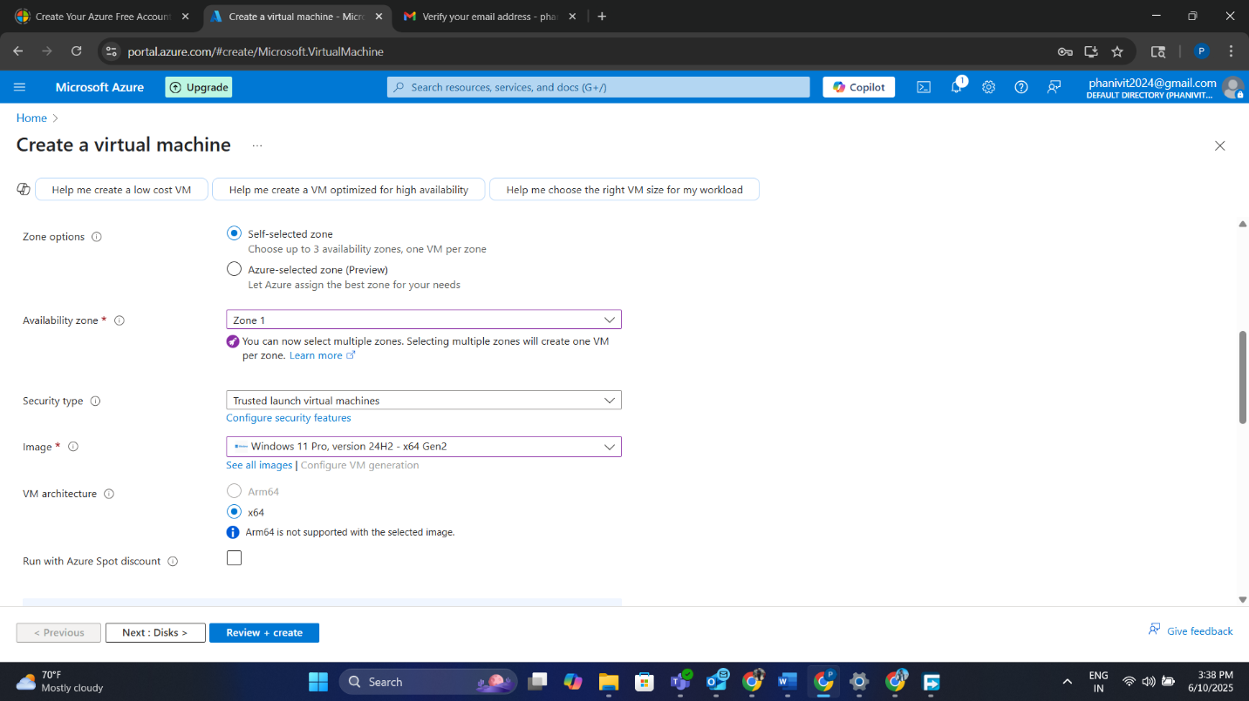

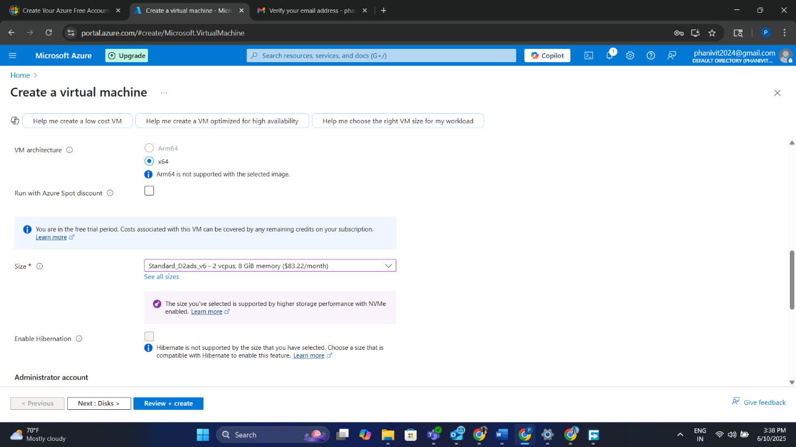

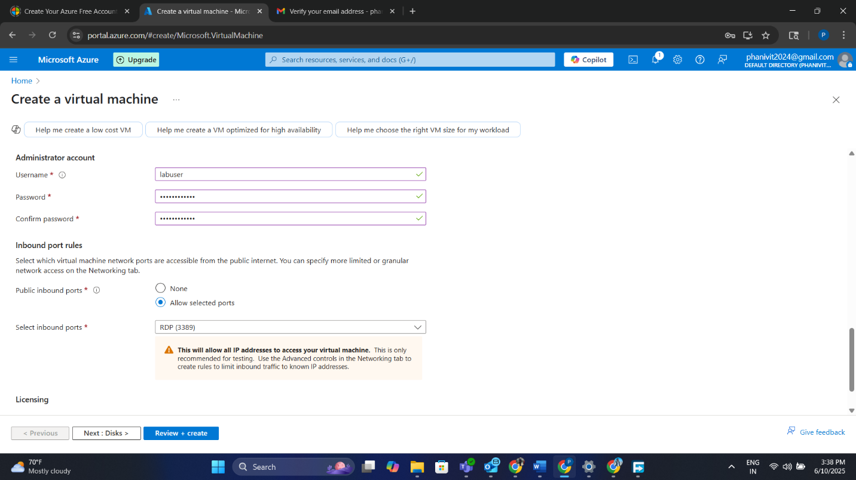

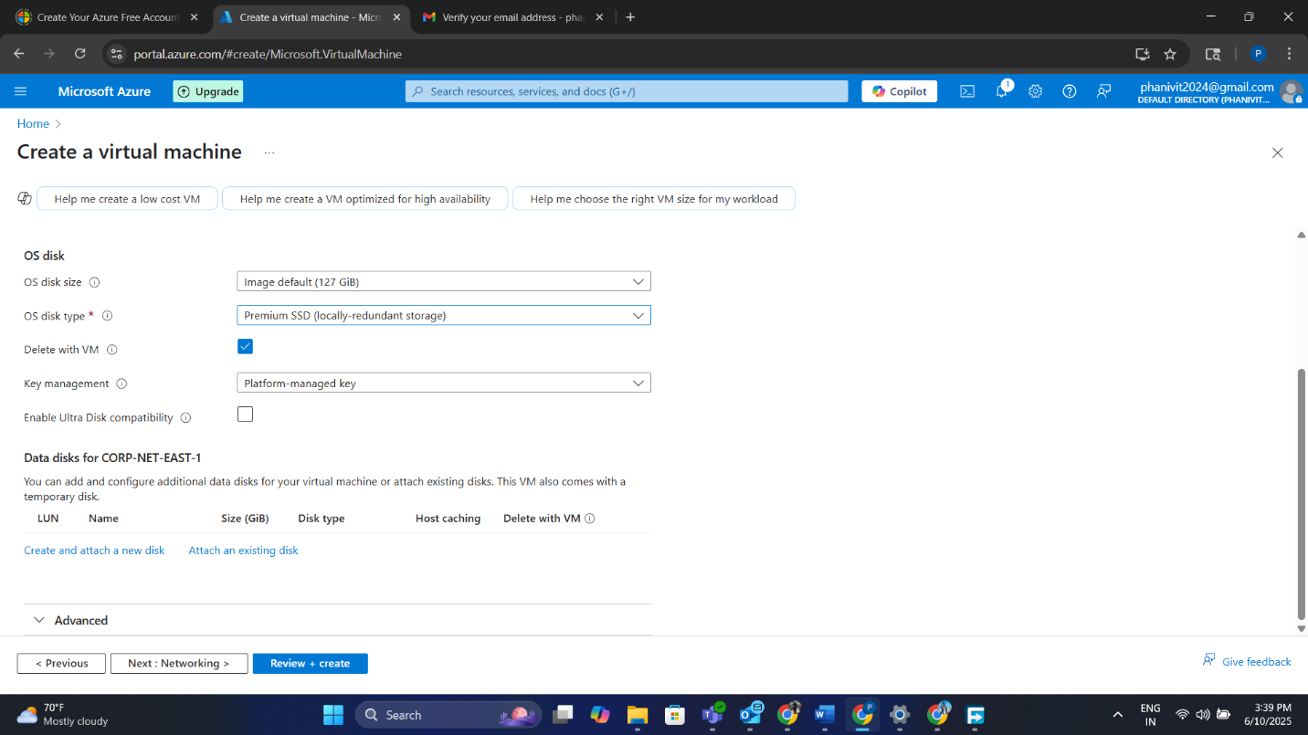

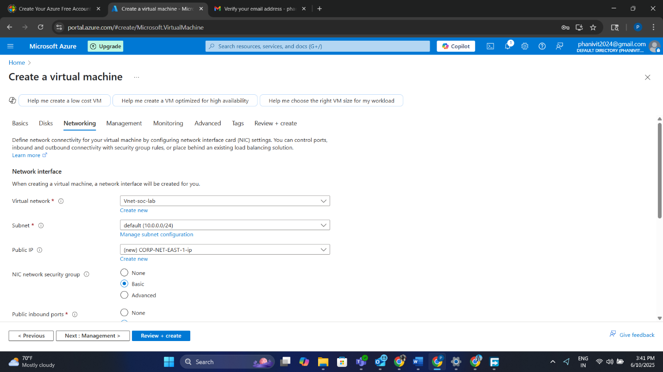

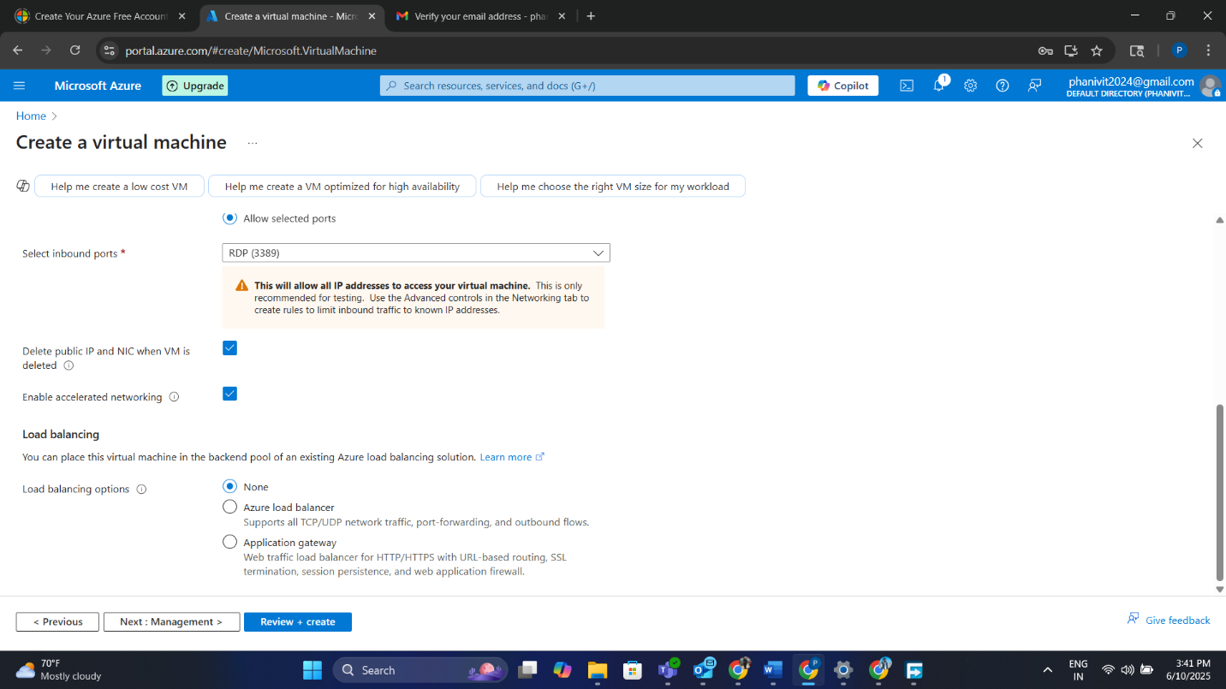

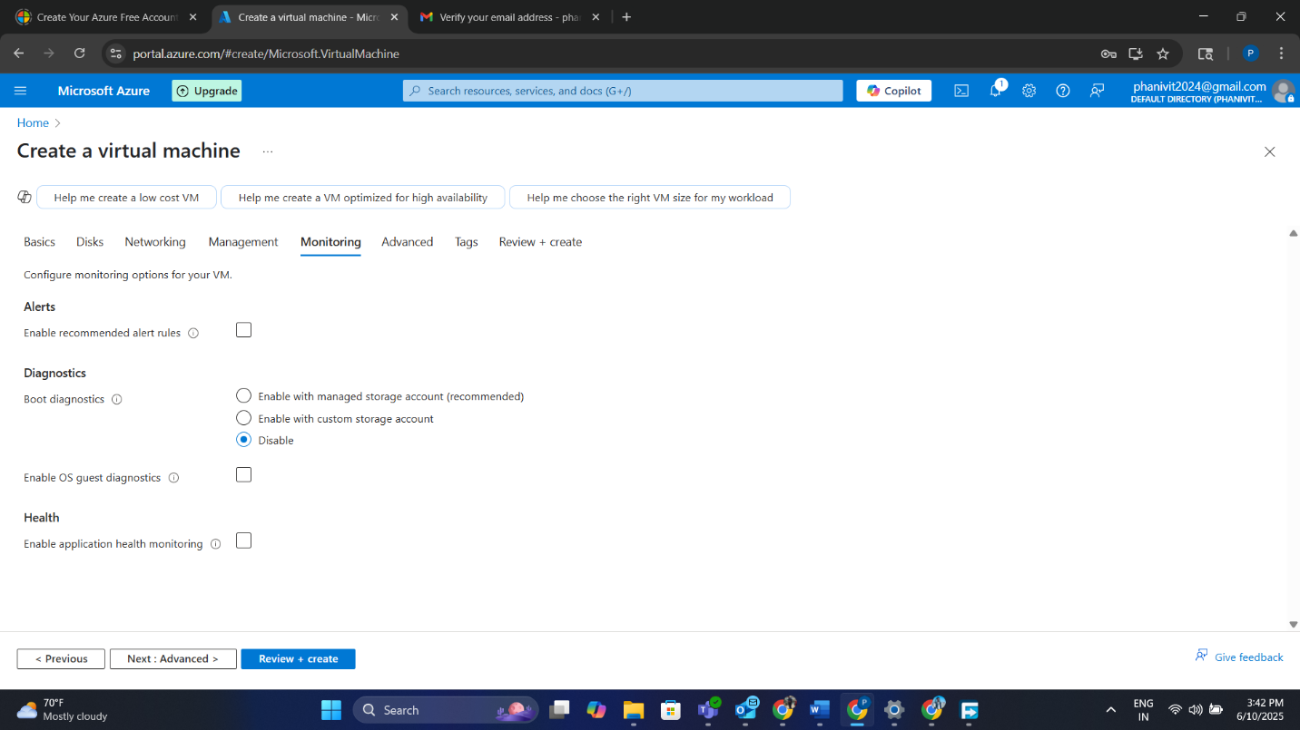

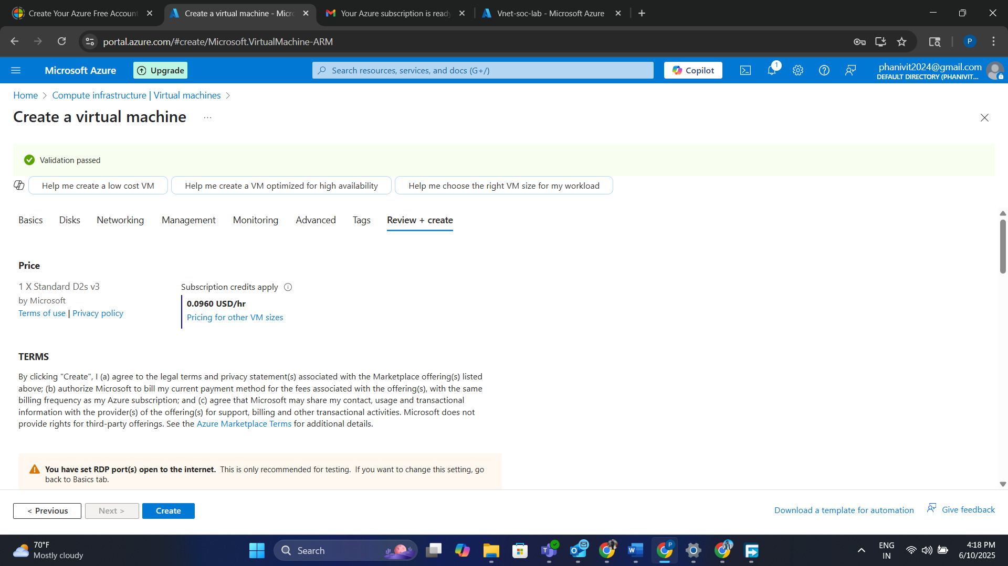

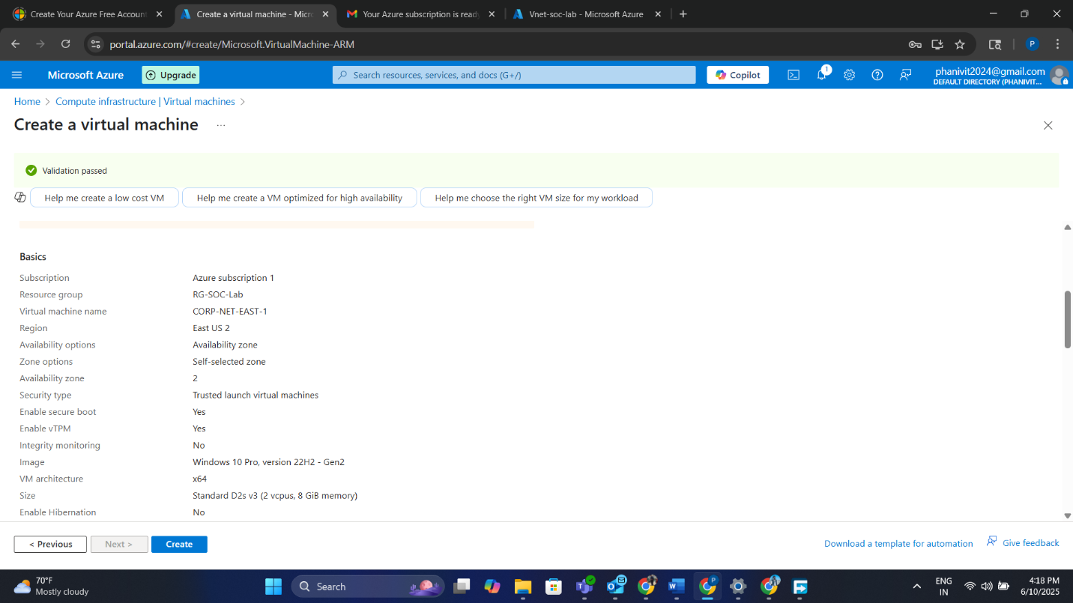

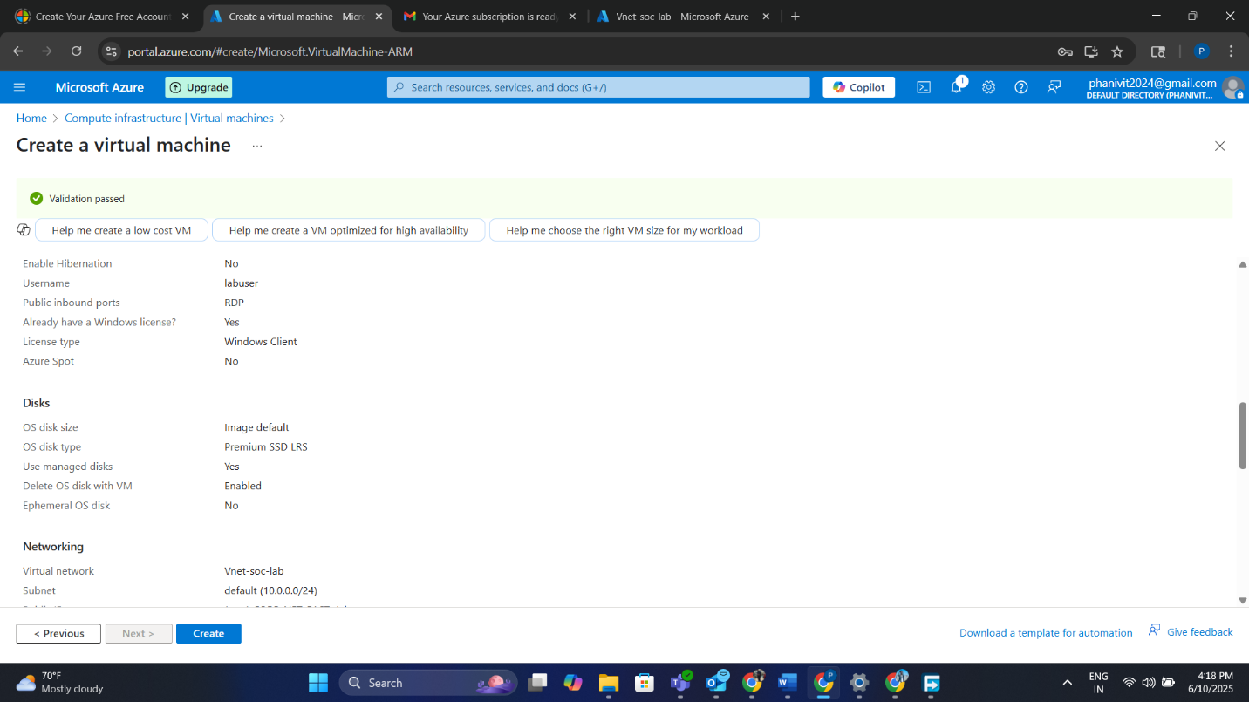

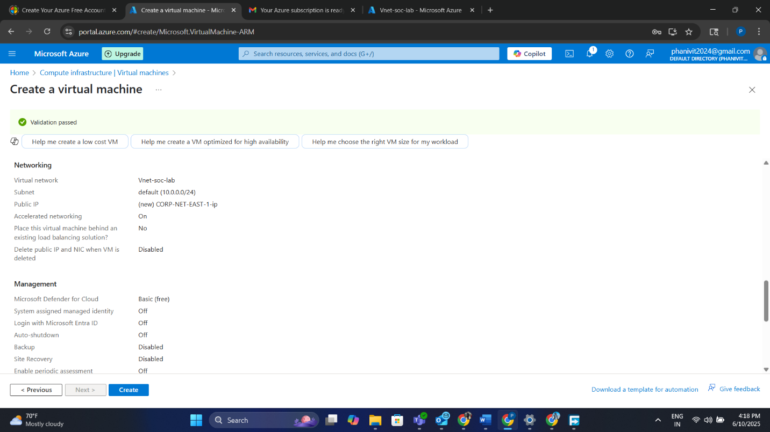

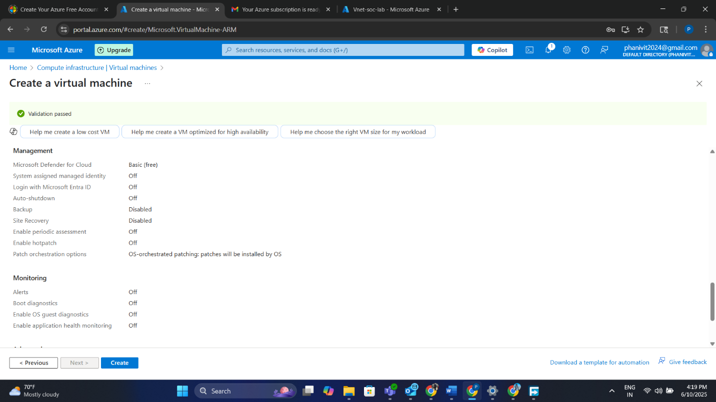

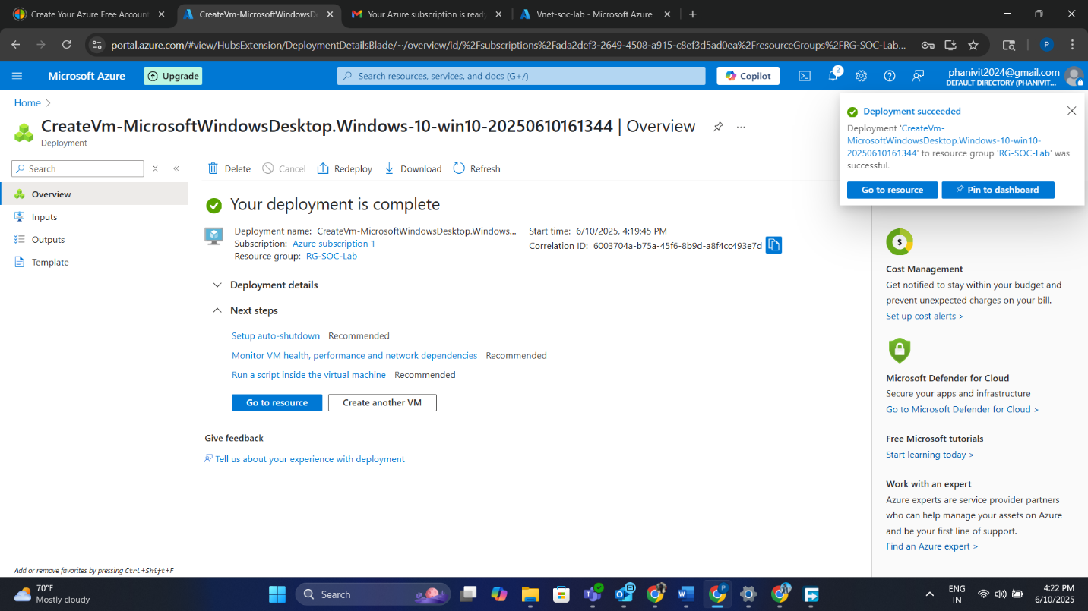

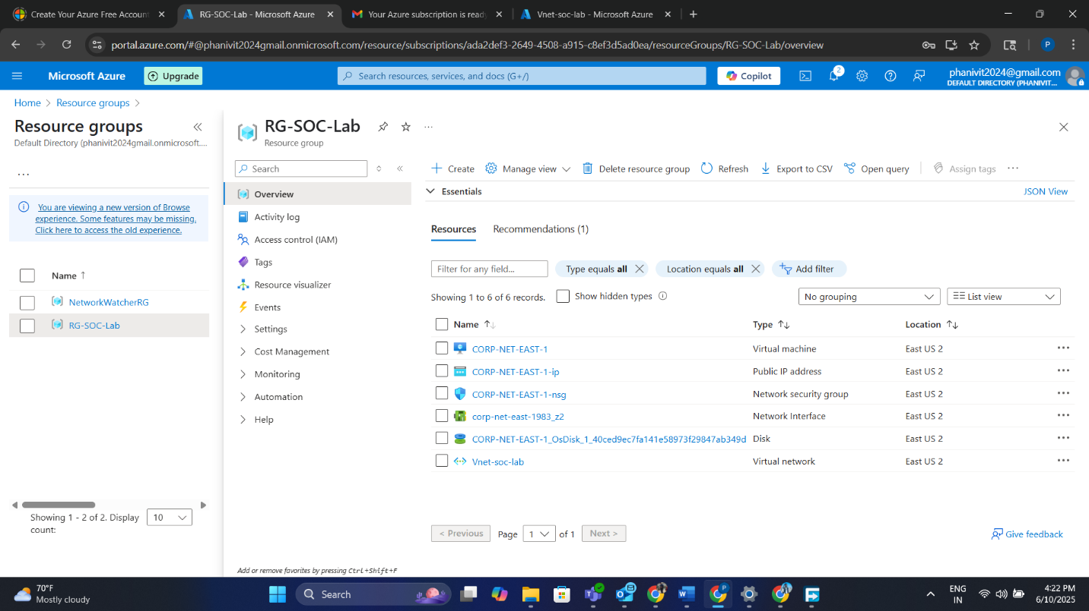

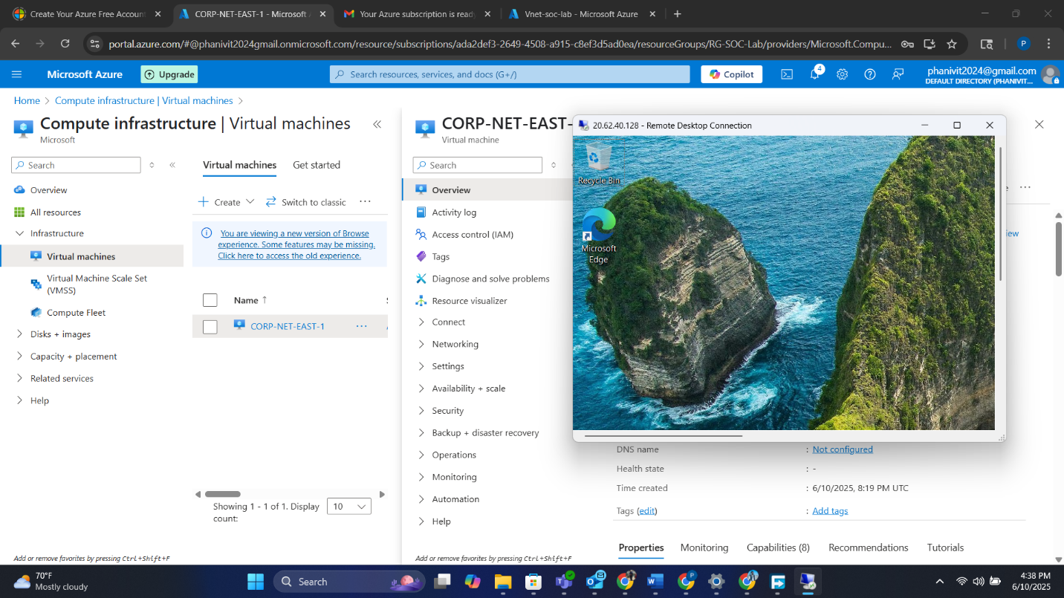

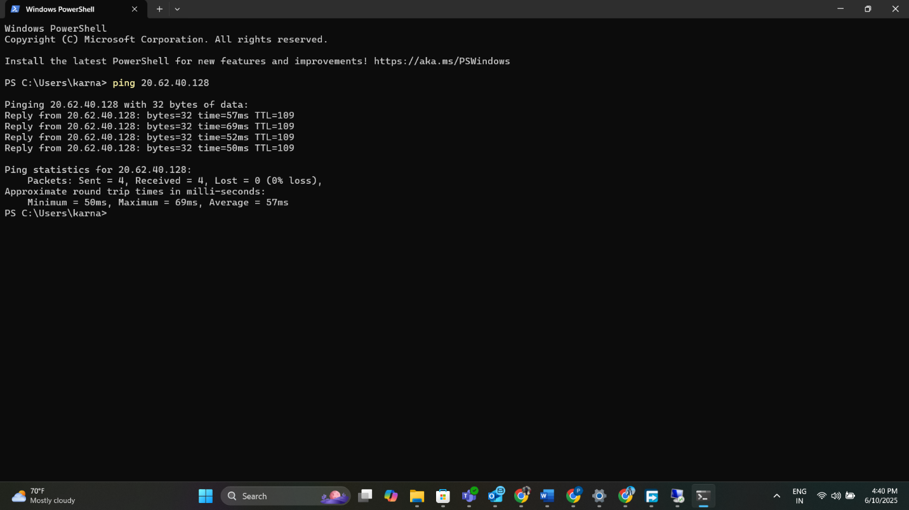

**5. Configuring Network Security Group (NSG)**

To allow attacker interaction:

* The default RDP-only inbound rule was deleted.
* A new inbound rule was added:
  + Source: Any
  + Destination: Any
  + Protocol: Any
  + Port Range: *
  + Action: Allow

This effectively opens the VM to all inbound traffic, simulating an exposed public system.

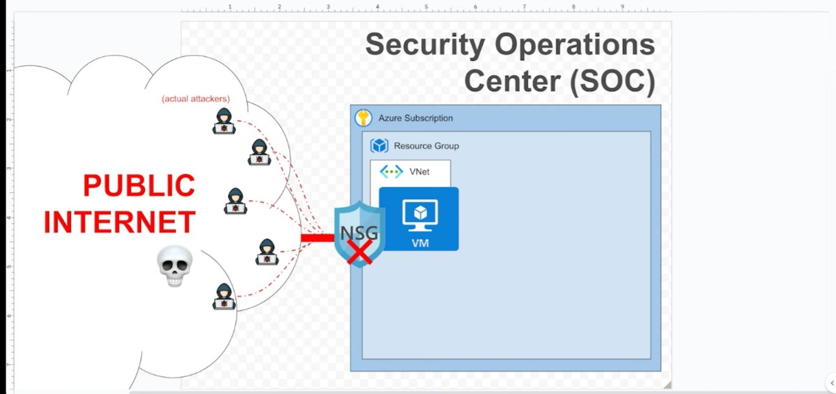

**6. Disabling Windows Defender Firewall**

To ensure all incoming traffic is logged:

* Remote Desktop Protocol (RDP) was used to log into the VM.
* Windows Firewall was accessed via wf.msc.
* The firewall was turned off for Domain, Private, and Public profiles.

This further simulates a vulnerable system and guarantees event logging.

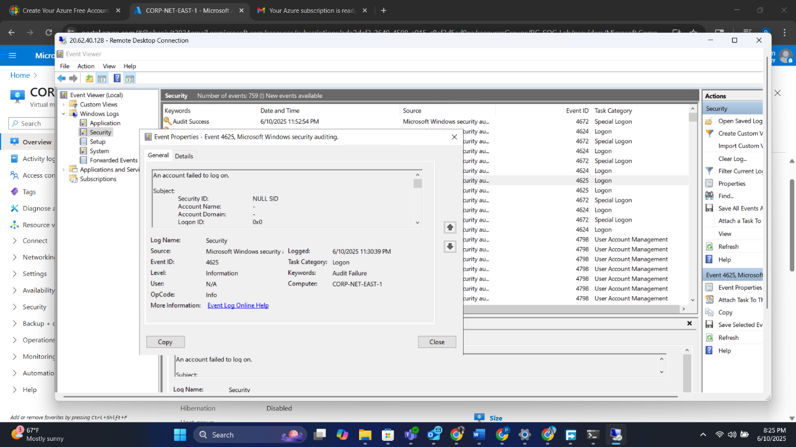

**7. Generating Simulated Attack Logs**

To simulate brute-force attempts:

* Several failed login attempts were made using fake usernames like employee.
* These actions triggered Windows Security Event ID 4625 (failed logon attempt).

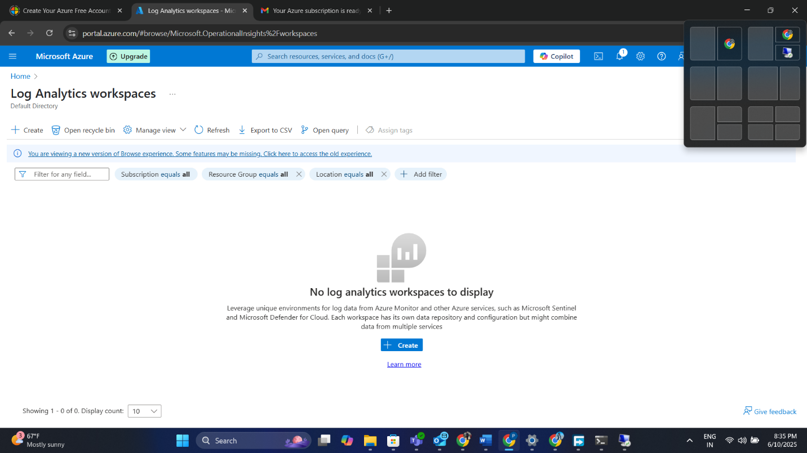

**8. Verifying Logs Using Event Viewer**

Within the VM:

* Event Viewer was opened.
* Navigated to: Windows Logs > Security
* Filtered logs by Event ID 4625.

Details such as the attempted username, source IP, and failure reasons were verified.

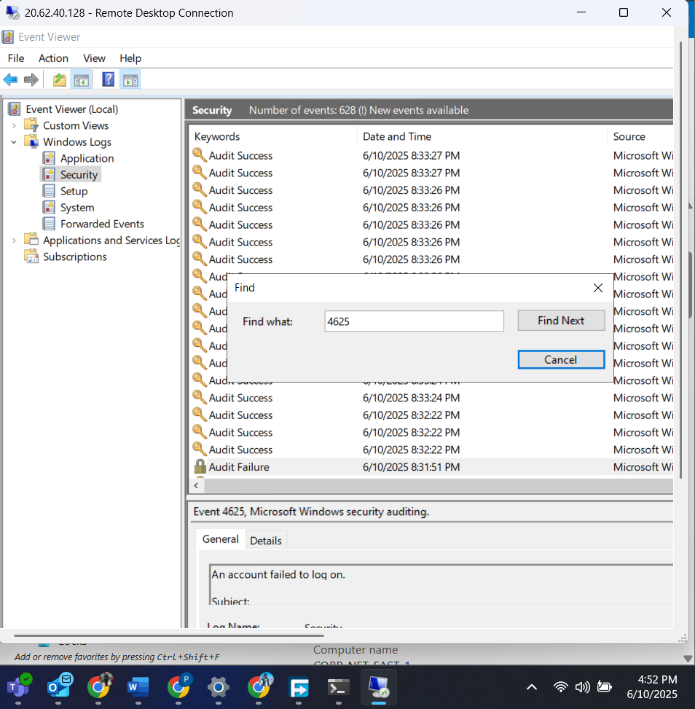

**9. Creating Log Analytics Workspace (LAW)**

A Log Analytics Workspace acts as a centralized repository:

* Created within **rg-socklab**
* Named **law-socklab-east2**
* Used to ingest logs forwarded from Azure resources, including VMs.

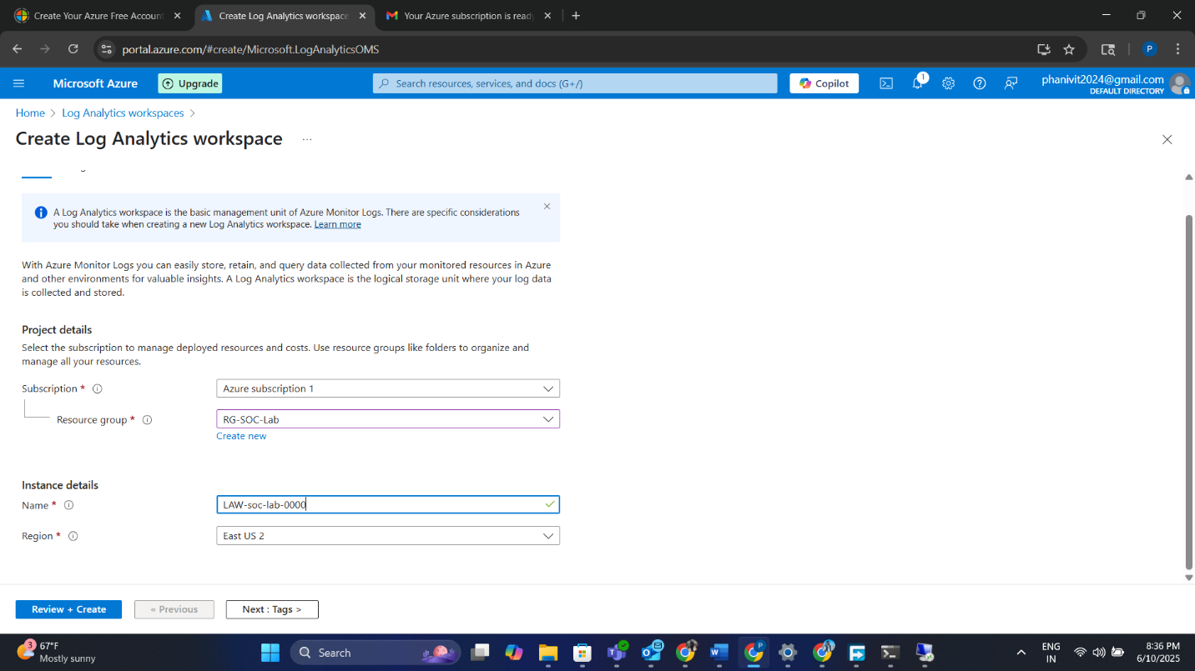

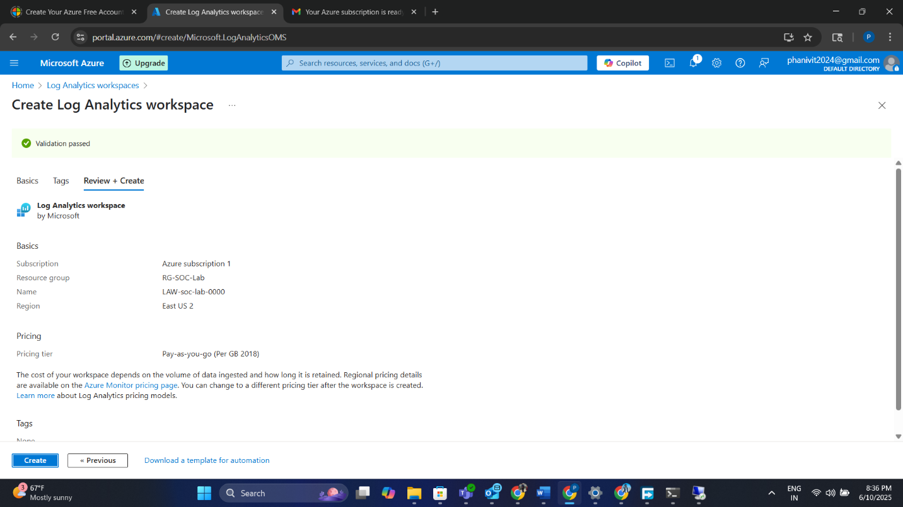

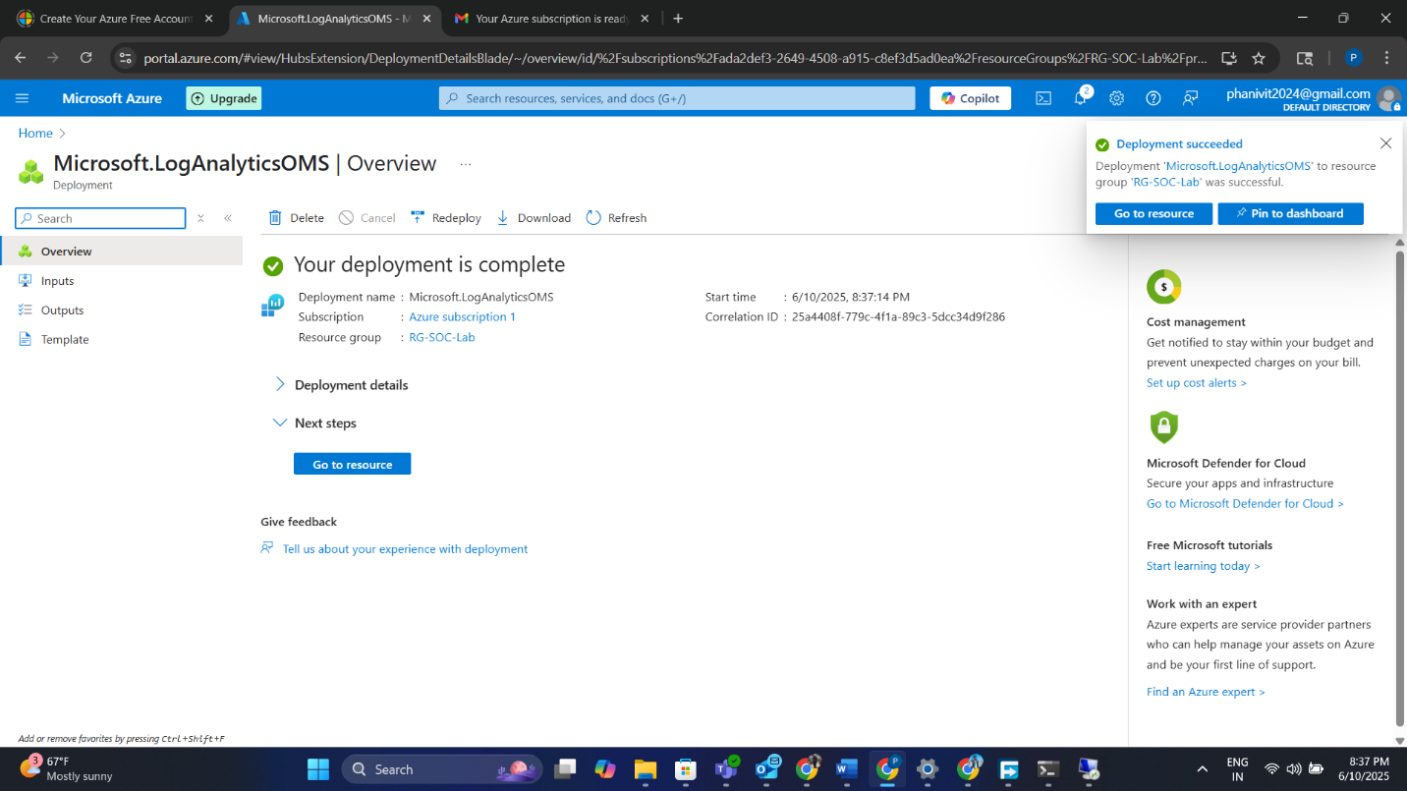

**10. Deploying Microsoft Sentinel Instance**

Microsoft Sentinel, a cloud-native SIEM/SOAR platform, was added to the LAW:

* The LAW created earlier was selected.
* Sentinel connects to LAW to run detection queries, dashboards, and incidents.

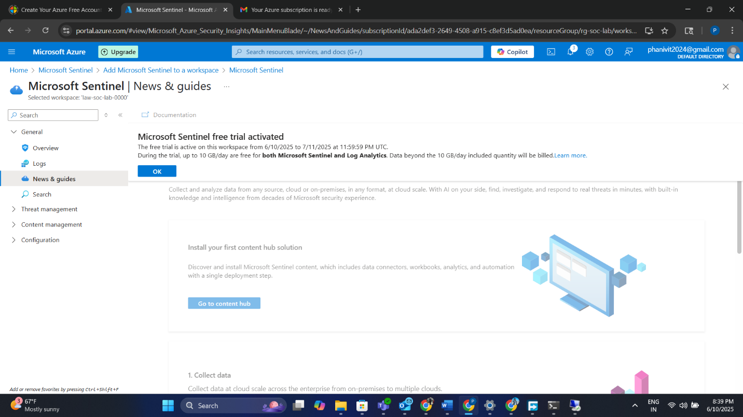

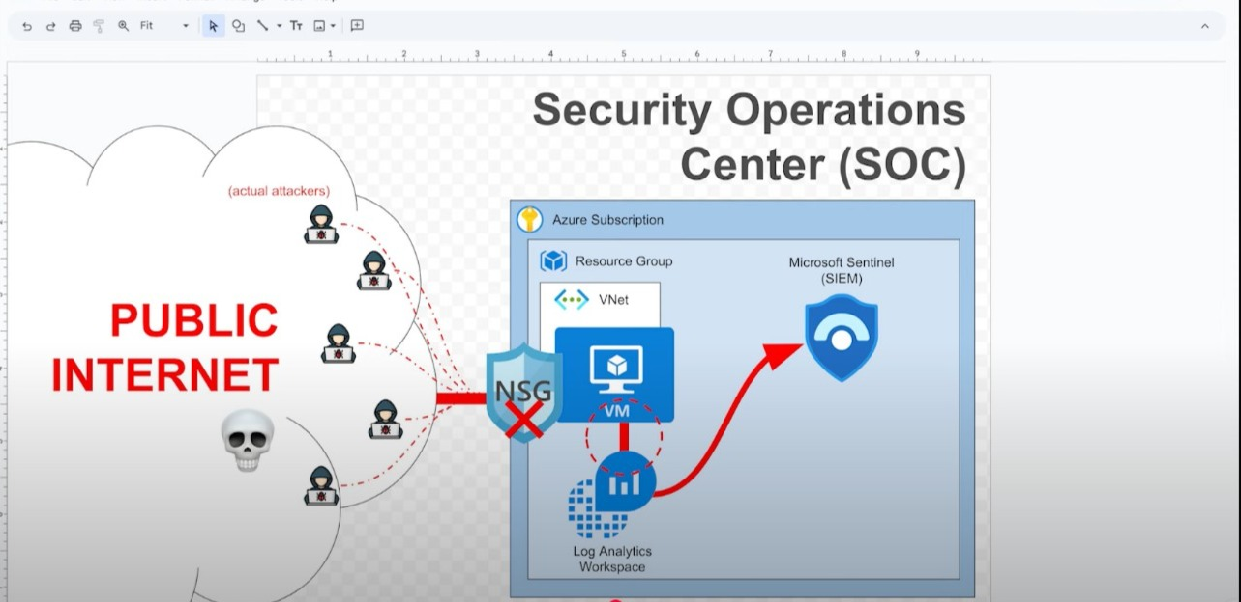

**11. Enabling Log Forwarding with Azure Monitoring Agent (AMA)**

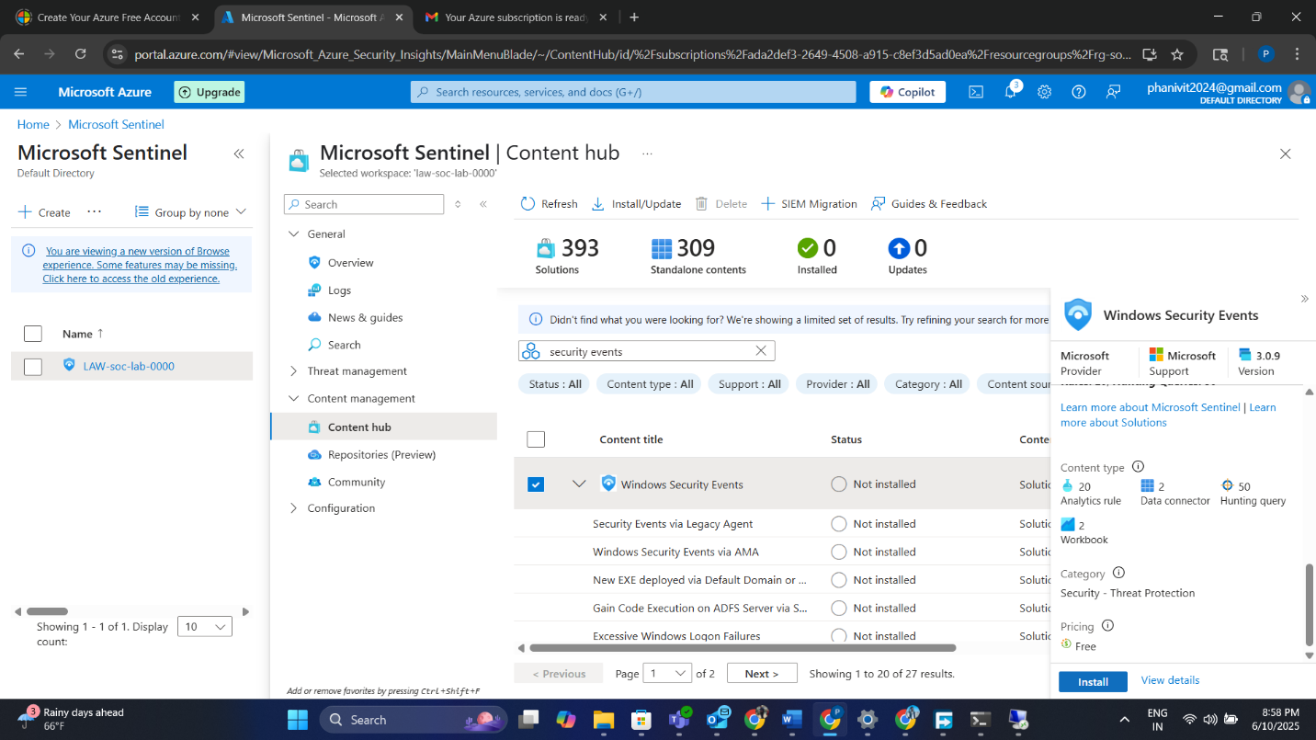

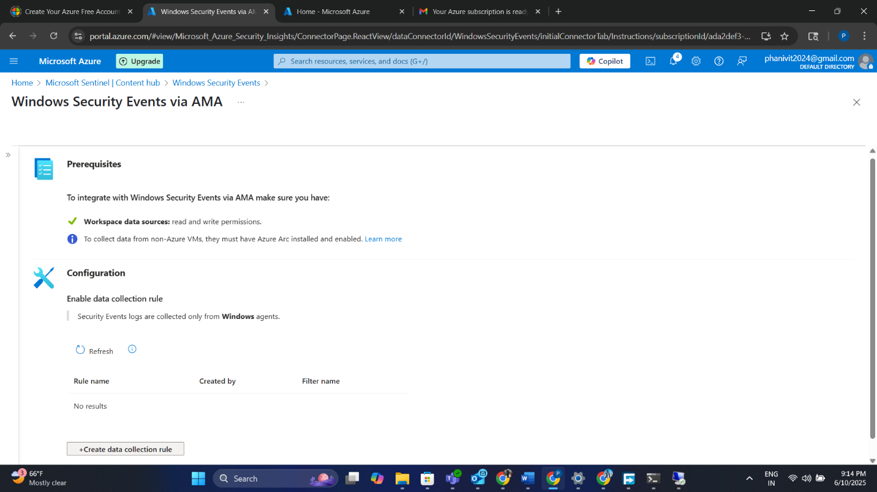

**To connect VM logs to LAW:**

* Windows Security Events Data Connector (Windows Security Events via AMA) was installed.

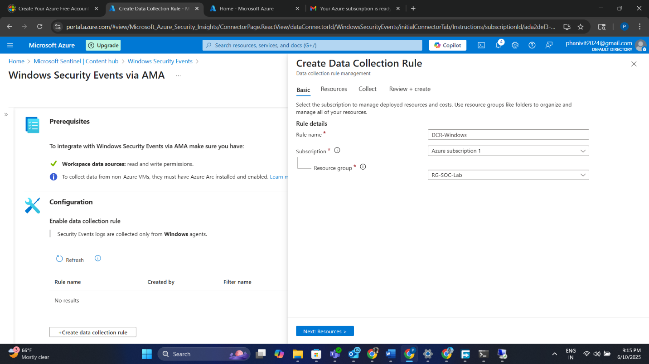

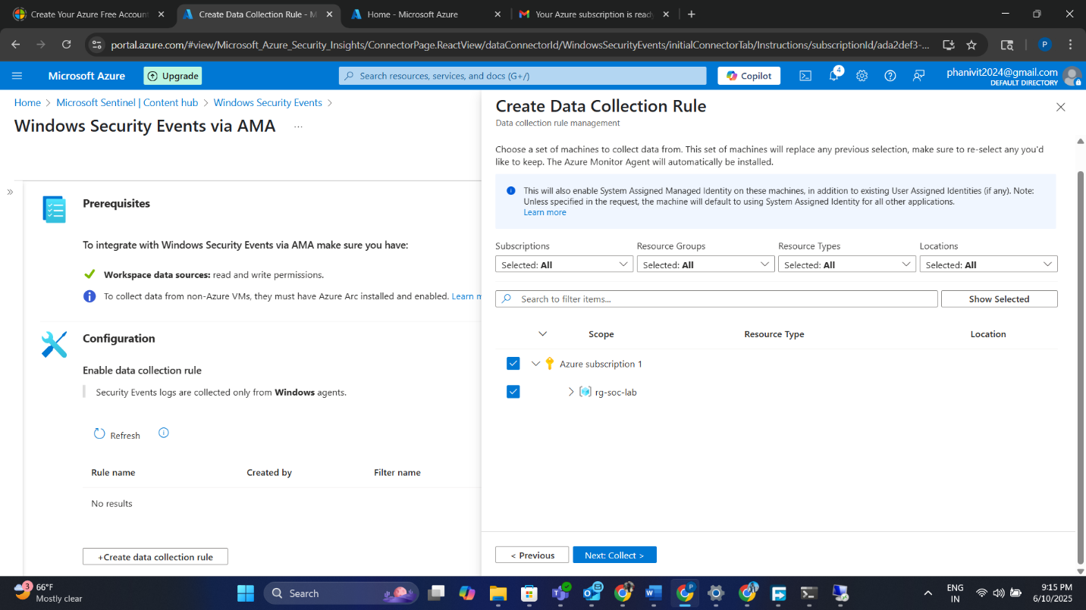

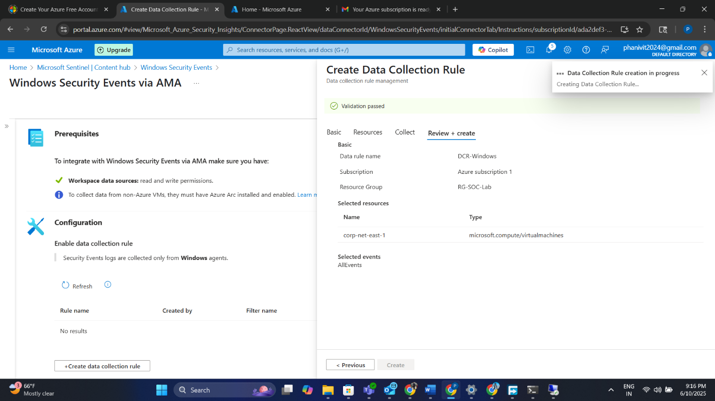

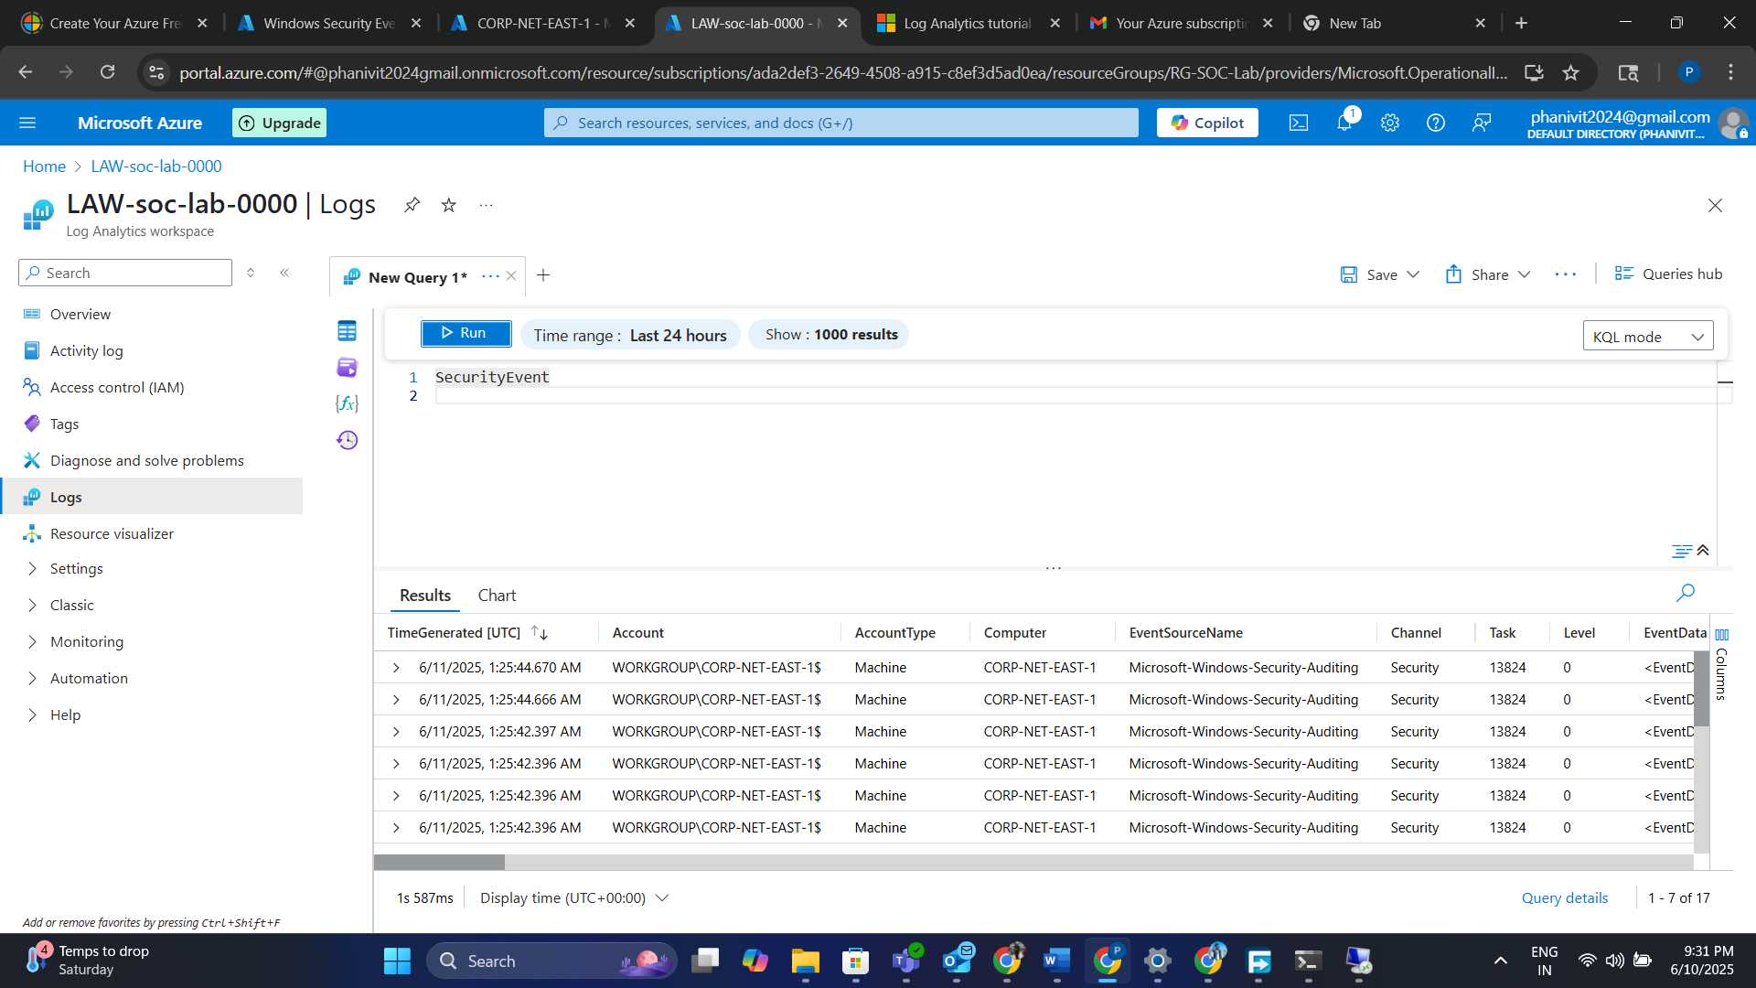

* A Data Collection Rule (**DCR**) was created to:
  + Link the VM to the LAW
  + Forward all security events

Confirmation of success was verified in the VM's Extensions tab.

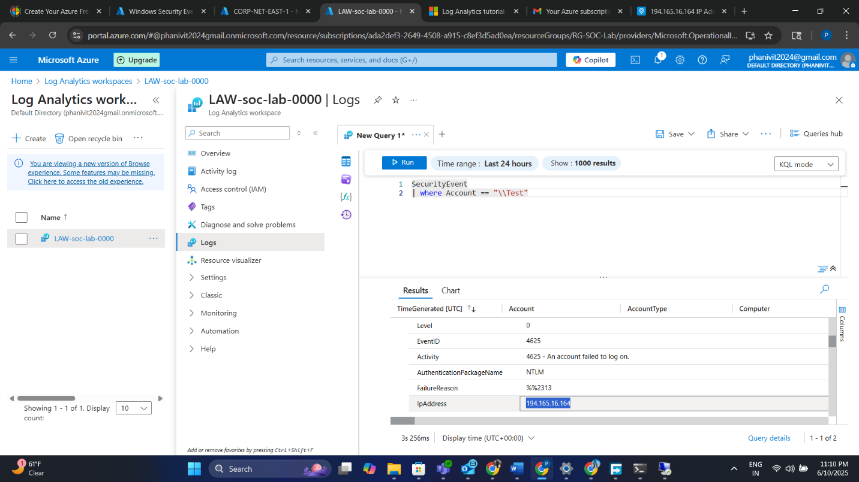

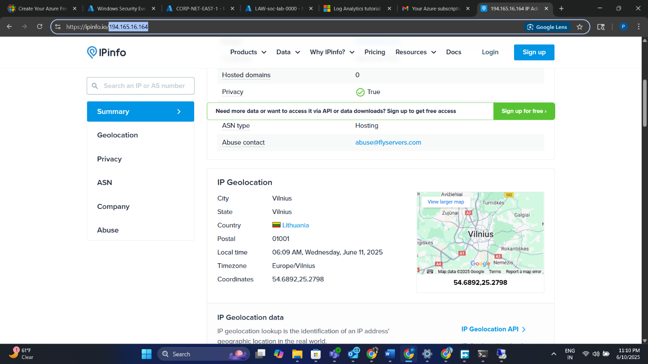

**12. Confirming Log Ingestion via KQL Queries**

In the LAW > Logs tab:

* Queried SecurityEvent table using KQL
* Verified presence of Event ID **4625**

Example query:

# SecurityEvent

| where EventID == 4625

| project TimeGenerated, Account, Computer, IPAddress #

Thousands of failed login attempts from global IPs appeared within minutes.

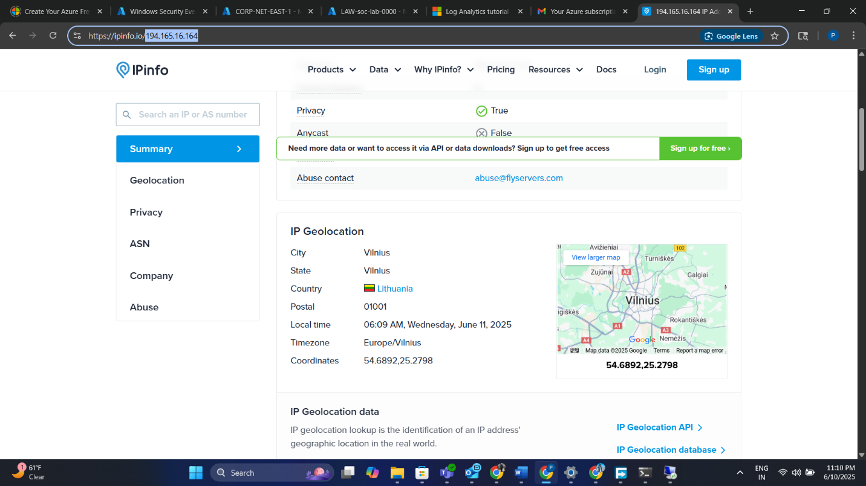

**13. Uploading GeoIP Watchlist to Sentinel**

To enrich IPs with location data:

* A CSV file (geoip-summarized.csv) was uploaded as a Watchlist in Sentinel
* Watchlist fields included: IP range, latitude, longitude, city, country
* Name and alias: GeoIP and geoip

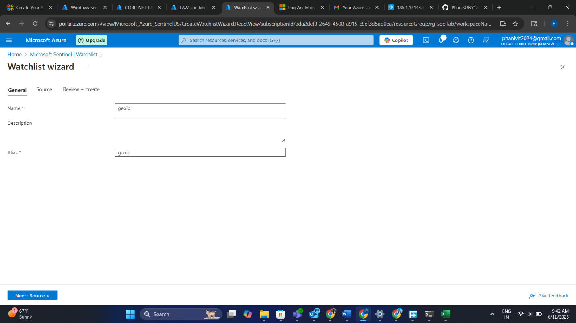

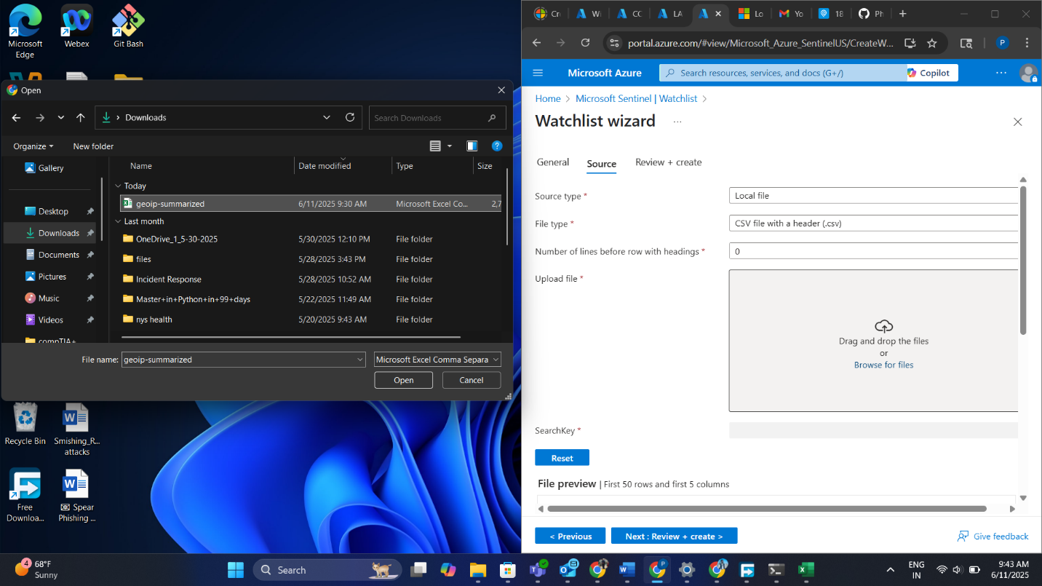

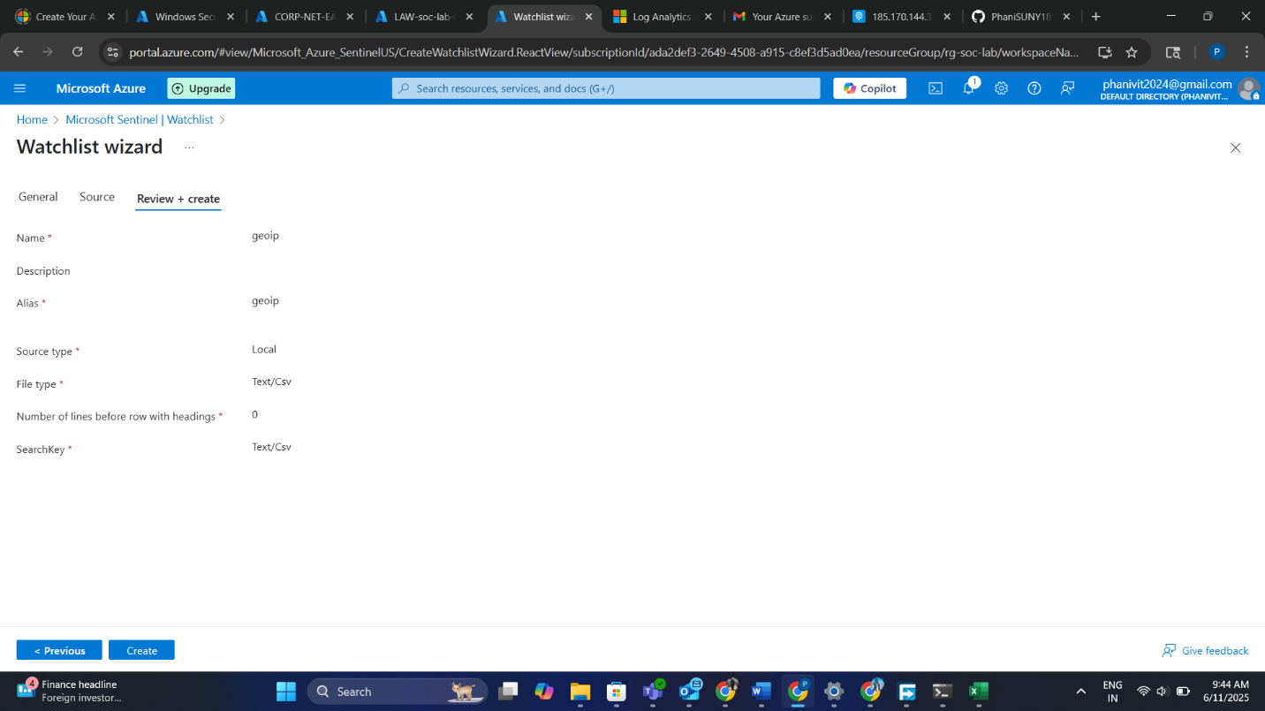

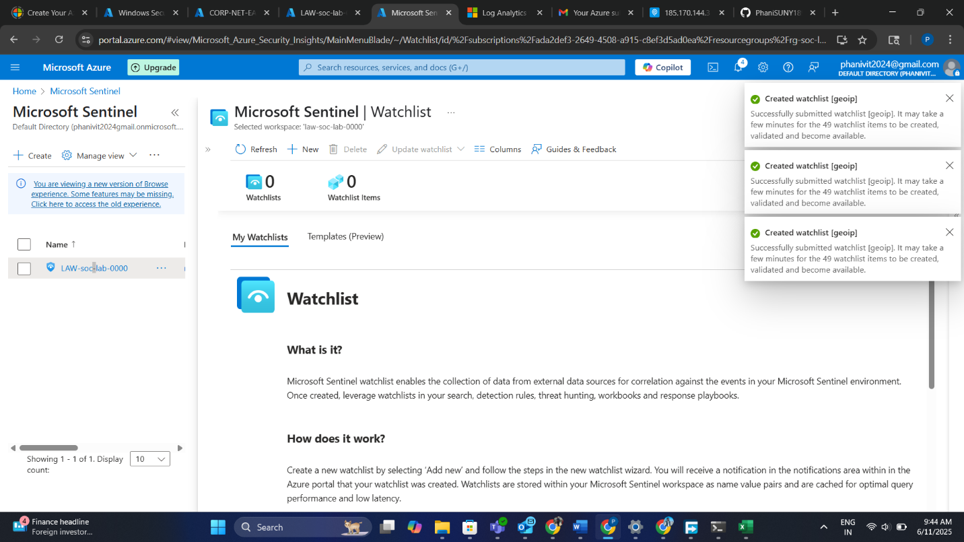

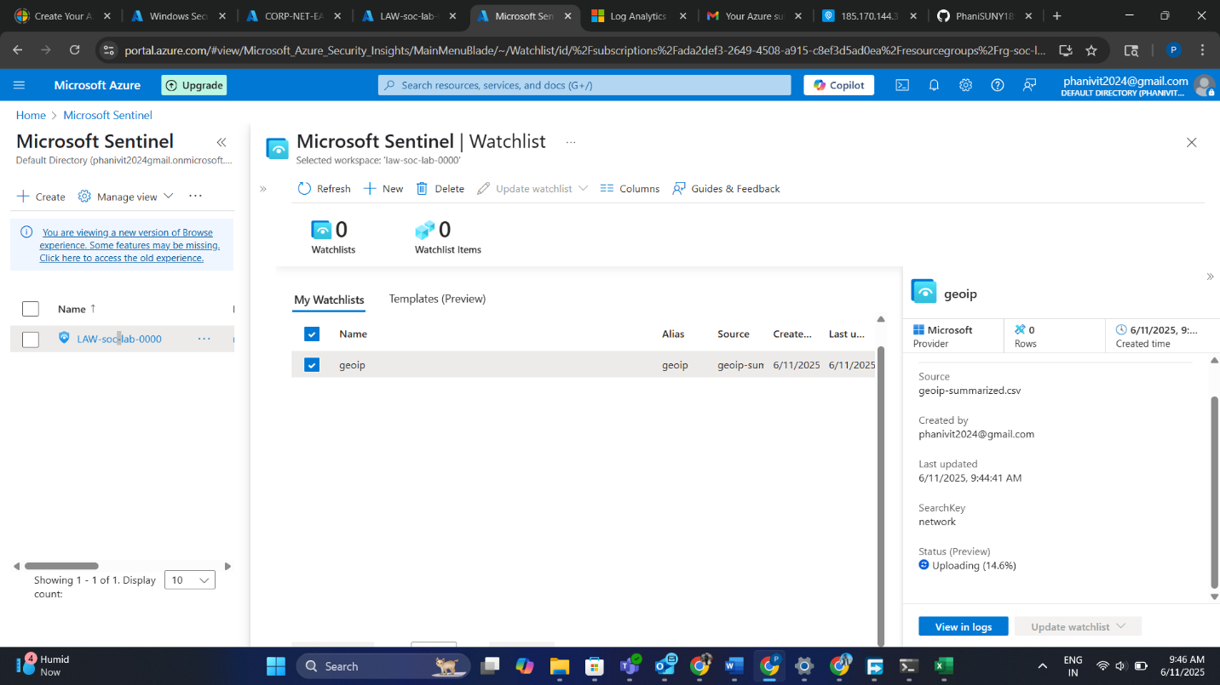

**14. Joining Security Logs with GeoIP Data**

Using KQL, logs were joined with the Watchlist to extract attacker locations:

let geo = _GetWatchlist("geoip");

SecurityEvent

| where EventID == 4625

| lookup kind=leftouter geo on $left.IPAddress == $right.Network

| project TimeGenerated, Account, IPAddress, CityName, CountryName, Latitude, Longitude

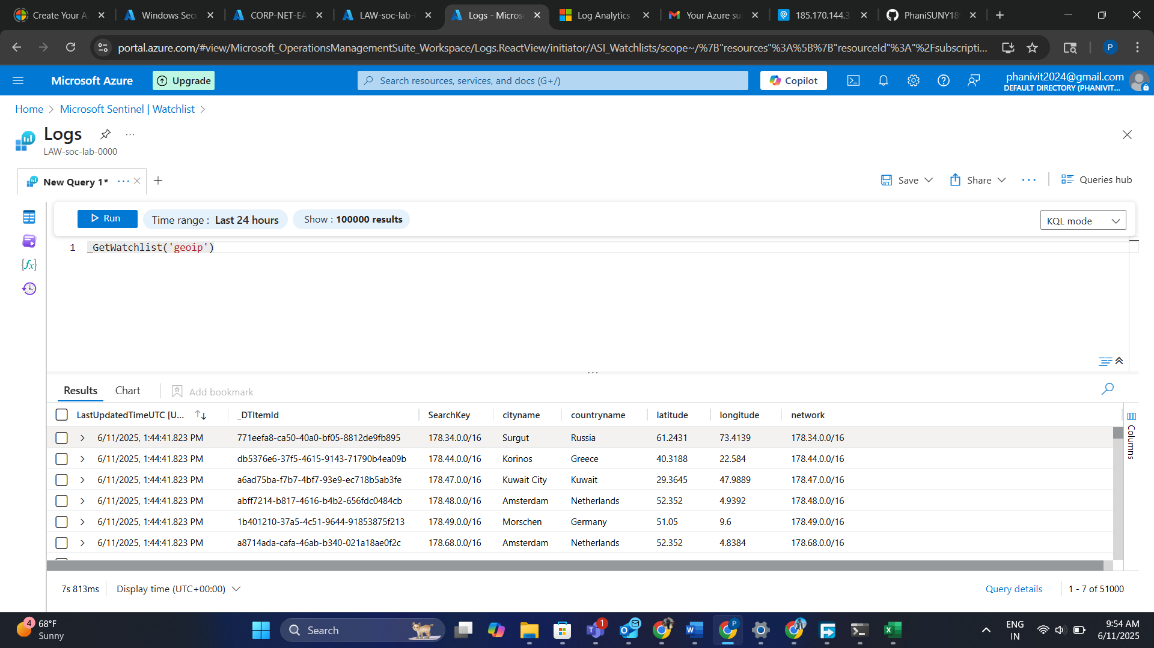

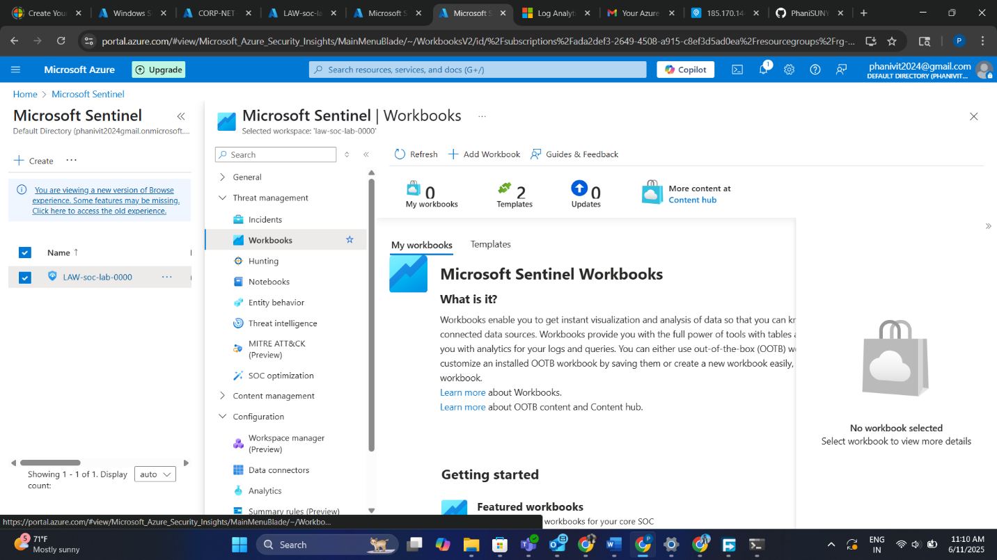

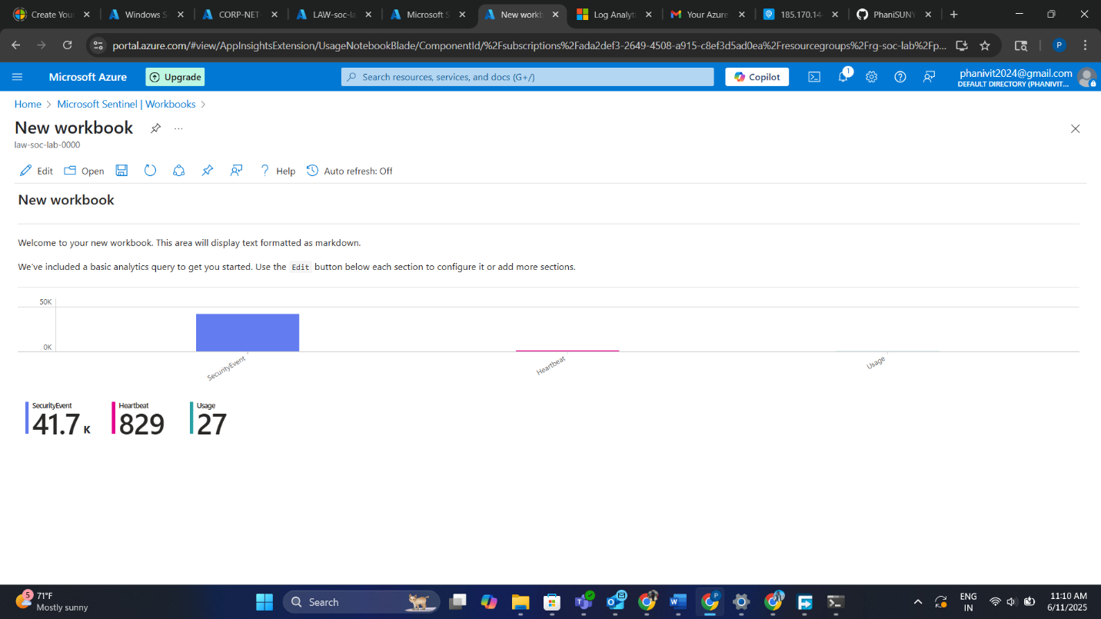

**15. Visualizing Attacks on World Map (Attack Map Workbook)**

A custom Sentinel Workbook was created:

* Visualized attacker locations using a heatmap
* JSON template from the lab was imported
* Map labeled by city + country
* Updated in real time as logs increased

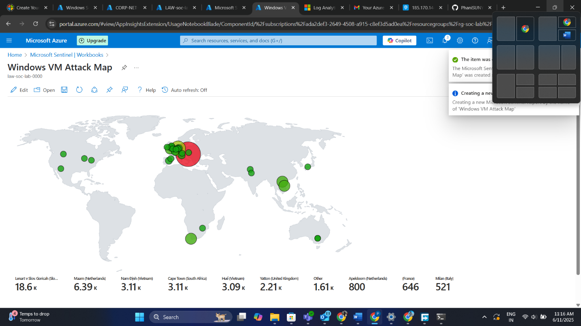

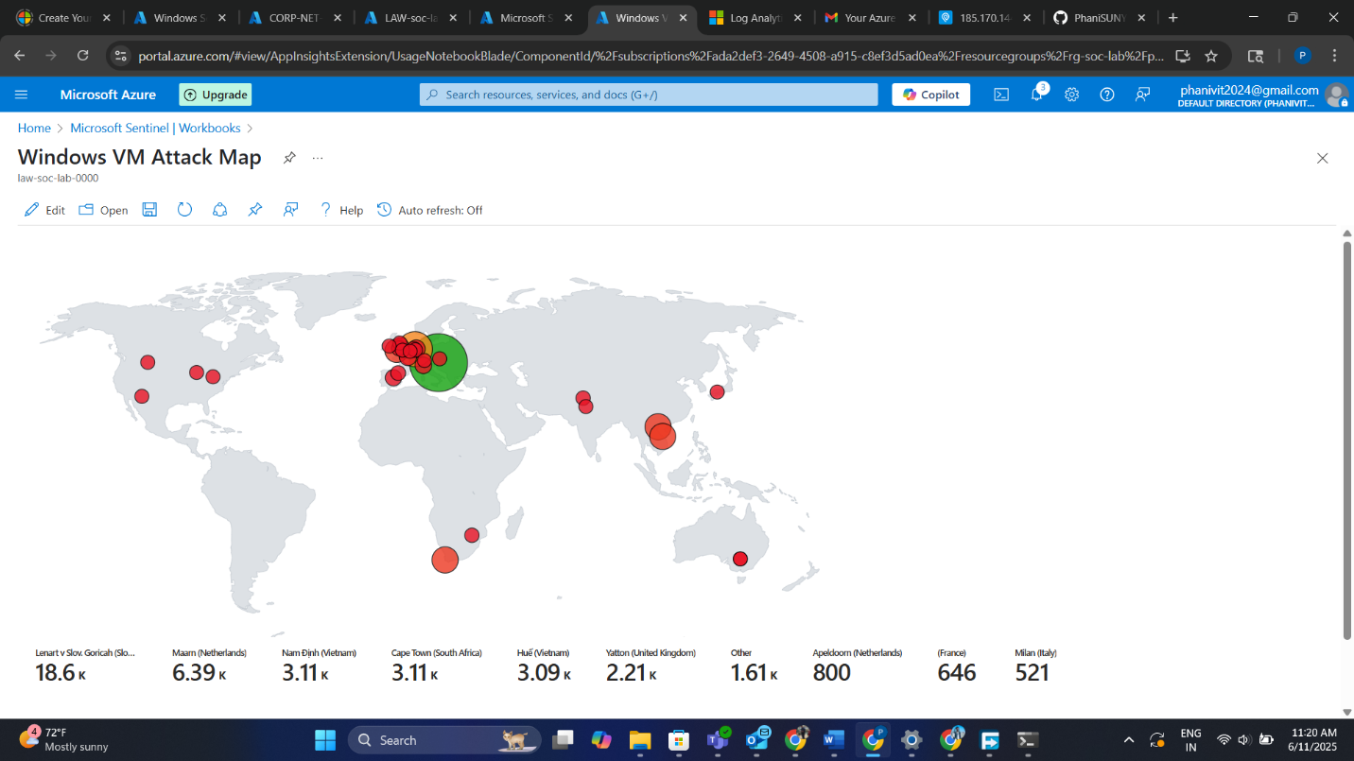

**Conclusion**

This lab simulates how real-world systems are probed and attacked almost instantly when exposed online. It teaches:

* Cloud infrastructure setup
* Vulnerability simulation
* Log ingestion and enrichment
* Security analytics with KQL
* Building geographic visualizations

Completing this lab is a strong portfolio item for aspiring SOC analysts, threat hunters, and cybersecurity engineers.

